A PROJECT REPORT

ON

MULTI-KEYWORD RANKED SEARCH OVER CLOUD ENCRYPTED DATA

SUBMITTED IN PRACTICAL FULFILLMENT OF THE REQUIREMENT

FOR THE AWARD OF DIPLOMA IN COMPUTER ENGINEERING

{2014-2017}



SUBMITTED BY

S.AJAY 14090-CM-016

T.DHANA SHEELA 14090-CM-017

B.RAKESH 14090-CM-022

A.SUPRIYA 14090-CM-024

G.MANIKUMAR 14090-CM-025

M.ARAVIND 14090-CM-035

V.SAITEJA 14090-CM-040

S.PRASHANTH 14090-CM-012

G.NAVEEN KUMAR 14090-CM-036

G.KARNAKAR 14090-CM-211

UNDER THE GUIDANCE OF

**R.MAHESH** (M.TECH)

DEPARTMENT OF COMPUTER ENGINEERING

VEMUGANTI MANOHAR RAO POLYTECHNIC.

RAMPUR , WARANGAL , TS-506142.

A PROJECT REPORT

ON

MULTI-KEYWORD RANKED SEARCH OVER CLOUD ENCRYPTED DATA

SUBMITTED IN PRACTICAL FULFILLMENT OF THE REQUIREMENT

FOR THE AWARD OF DIPLOMA IN COMPUTER ENGINEERING

{2014-2017}



SUBMITTED BY

S.AJAY 14090-CM-016

T.DHANA SHEELA 14090-CM-017

B.RAKESH 14090-CM-022

A.SUPRIYA 14090-CM-024

G.MANIKUMAR 14090-CM-025

M.ARAVIND 14090-CM-035

V.SAITEJA 14090-CM-040

S.PRASHANTH 14090-CM-012

G.NAVEEN KUMAR 14090-CM-036

G.KARNAKAR 14090-CM-211

UNDER THE GUIDANCE OF

**R.MAHESH** (M.TECH)

DEPARTMENT OF COMPUTER ENGINEERING

VEMUGANTI MANOHAR RAO POLYTECHNIC.

RAMPUR , WARANGAL , TS-506142.

VEMUGANTI MANOHAR RAO POLYTECHNIC

AFFILIATED SBTET-TS , HYDERABAD.

**RAMPUR, WARANGAL - 506142(TS)**



CERTIFICATE

THIS IS TO CERTIFY THAT THE DISSERTATION WORK ENTITLED

**MULTI-KEYWORD RANKED SEARCH OVER CLOUD ENCRYPTED DATA** IS

THE WORK DONE BY **S.AJAY,** PARTIAL FULFILLMENT FOR THE

AWARD OF **DIPLOMA IN COMPUTER ENGINEERING** AND SUBMITTED TO

THE STATE BOARD OF TECHNICAL EDUCATION AND TRAINING (TS) HYDERABAD

IS AWARD OF BONAFIED WORK CARRIED OUT BY THEM UNDER OUR GUIDANCE

AND SUPERVISION.THE RESULTS EMBODIED IN THIS PROJECT REPORT HAVE

NOT BEEN SUBMITTED TO ANY OTHER IN INSTITUTIONS FOR THE AWARD OF DIPLOMA.

**GUIDE HOD PRINCIPAL**

**R.MAHESH B.RAJAMOLI V.PRADEEP KUMAR**

**EXTERNAL EXAMINER**

ACKNOWLEDGEMNT

I WISH TO EXPRESS MY HEALTHY GRATITUDE TO SRI.V.**PRADEEP KUMAR**, PRINCIPAL SECRETARY AND CORRESPONDENT OF **VEMUGANTI MANOHAR RAO POLYTECHNIC RAMPUR, WARANGAL** FOR PROVIDING ALL THE FACILITIES REQUIRED FOR THE SEMINAR EPRESNTATION.

WE WISH TO TAKE THIS OPPORTUNITY TO EXPRESS OUR SINCERE THANKS TO **B.RAJAMOLI** HEAD OF THE DEPARTMENT FOR THE INTEREST TECHNICAL SUPPORT AND SUGGESTIONS DURING THE SEMINAR LEADING TO OUR SUCCESS.

WE ARE OBLIGED AND GRATEFUL TO MY GUIDE **R.MAHESH** LECTURER OF **CME** DEPARTMENT FOR HER VALUABLE SUGGESTIONS AND SAGACIOUS GUIDANCE IN ALL ASPECTS DURING THE TECHNICAL OF OUR TRAINING.

WE HEREBY EXPRESS MY SINCERE THANKS REGARDS TO ALL TEACHING STAFF, PARENTS AND FRIENDS WHO EXTENDE THEIR HELP HAND IN THE ACCOMPLISHED OF THE PROJECT.

PLACE : RAMPUR YOURS SINCERELY

DATE : **S.AJAY**

14090-CM-016.

**ABSTRACT**

Due to the increasing popularity of cloud computing, more and more data owners are motivated to outsource their data to cloud servers for great convenience and reduced cost in data management. However, sensitive data should be encrypted before outsourcing for privacy requirements, which obsoletes data utilization like keyword-based document retrieval. In this paper, we present a secure multi-keyword ranked search scheme over encrypted cloud data, which simultaneously supports dynamic update operations like deletion and insertion of documents. Specifically, the vector space model and the widely-used TF_IDF model are combined in the index construction and query generation. We construct a special tree-based index structure and propose a “Greedy Depth-first Search” algorithm to provide efficient multi-keyword ranked search. The secure kNN algorithm is utilized to encrypt the index and query vectors, and meanwhile ensure accurate relevance score calculation between encrypted index and query vectors. In order to resist statistical attacks, phantom terms are added to the index vector for blinding search results. Due to the use of our special tree-based index structure, the proposed scheme can achieve sub-linear search time and deal with the deletion and insertion of documents flexibly. Extensive experiments are conducted to demonstrate the efficiency of the proposed scheme.

**INTRODUCTION**

Both parallel and distributed systems can be defined as a collection of processing elements that communicate and cooperate to achieve a common goal. Advances in processor technology have resulted in today's computer systems using parallelism at all levels: within each CPU by executing multiple instructions from the same thread of control simultaneously (superscalar architectures/instruction-level parallelism); by executing multiple instructions from different threads of control simultaneously (simultaneous multithreading); by introducing multiple cores in a single chip (chip multiprocessors); by using multiple chips to form multiprocessors; or via multiple networked nodes to form a cluster; making parallel systems increasingly ubiquitous.

Simultaneously, advances in networking technology have created an explosion of distributed applications, making distributed computing an inherent fabric in our day-to-day lives. This course will focus on the principles of parallel and distributed systems and the implementation and performance issues associated with them. We will examine programming models/interfaces to parallel and distributed computing, interprocess communication, synchronization and consistency models, fault tolerance and reliability, distributed process management, parallel machine architectures, parallel program optimization, and the interaction of the compiler, run-time, and machine architecture.

Difference between distributed system and parallel system are given below:

* Distributed Operating systems are also referred to as Loosely Coupled systems whereas parallel processing systems are referred to as loosely coupled systems.
* A Loosley coupled system is one in which the processors do not share memory and each processor has its own local memory whereas in a tightly coupled system there is a single system wide primary memory shared by all the processors.
* The processors of distributed operating systems can be placed far away from each other to cover a wider geographic area which is not the case with parallel processing systems.
* The no. of processors that can be usefully deployed is very small in a parallel processing operating system whereas for a distributed operating system a larger no. of processors can be usefully deployed

**DISTRIBUTED COMPUTING:**

A distributed system is a network of autonomous computers that communicate with each other in order to achieve a goal. The computers in a distributed system are independent and do not physically share memory or processors. They communicate with each other using *messages*, pieces of information transferred from one computer to another over a network. Messages can communicate many things: computers can tell other computers to execute a procedures with particular arguments, they can send and receive packets of data, or send signals that tell other computers to behave a certain way.

Computers in a distributed system can have different roles. A computer's role depends on the goal of the system and the computer's own hardware and software properties. There are two predominant ways of organizing computers in a distributed system. The first is the client-server architecture, and the second is the peer-to-peer architecture.

**CLIENT/SERVER SYSTEMS:**

The client-server architecture is a way to dispense a service from a central source. There is a single server that provides a service, and multiple clients that communicate with the server to consume its products. In this architecture, clients and servers have different jobs. The server's job is to respond to service requests from clients, while a client's job is to use the data provided in response in order to perform some task.

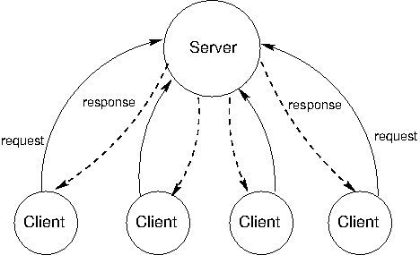

The client-server model of communication can be traced back to the introduction of UNIX in the 1970's, but perhaps the most influential use of the model is the modern World Wide Web. An example of a client-server interaction is reading the New York Times online. When the web server at www.nytimes.com is contacted by a web browsing client (like Firefox), its job is to send back the HTML of the New York Times main page. This could involve calculating personalized content based on user account information sent by the client, and fetching appropriate advertisements. The job of the web browsing client is to render the HTML code sent by the server. This means displaying the images, arranging the content visually, showing different colors, fonts, and shapes and allowing users to interact with the rendered web page.

The concepts of client and server are powerful functional abstractions. A server is simply a unit that provides a service, possibly to multiple clients simultaneously, and a client is a unit that consumes the service. The clients do not need to know the details of how the service is provided, or how the data they are receiving is stored or calculated, and the server does not need to know how the data is going to be used.

On the web, we think of clients and servers as being on different machines, but even systems on a single machine can have client/server architectures. For example, signals from input devices on a computer need to be generally available to programs running on the computer. The programs are clients, consuming mouse and keyboard input data. The operating system's device drivers are the servers, taking in physical signals and serving them up as usable input.

A drawback of client-server systems is that the server is a single point of failure. It is the only component with the ability to dispense the service. There can be any number of clients, which are interchangeable and can come and go as necessary. If the server goes down, however, the system stops working. Thus, the functional abstraction created by the client-server architecture also makes it vulnerable to failure.

Another drawback of client-server systems is that resources become scarce if there are too many clients. Clients increase the demand on the system without contributing any computing resources. Client-server systems cannot shrink and grow with changing demand.

[**PEER-TO-PEER SYSTEMS**](http://wla.berkeley.edu/~cs61a/fa11/lectures/communication.html#id4)**:**

The client-server model is appropriate for service-oriented situations. However, there are other computational goals for which a more equal division of labor is a better choice. The term peer-to-peer is used to describe distributed systems in which labor is divided among all the components of the system. All the computers send and receive data, and they all contribute some processing power and memory. As a distributed system increases in size, its capacity of computational resources increases. In a peer-to-peer system, all components of the system contribute some processing power and memory to a distributed computation.

Division of labor among all participants is the identifying characteristic of a peer-to-peer system. This means that peers need to be able to communicate with each other reliably. In order to make sure that messages reach their intended destinations, peer-to-peer systems need to have an organized network structure. The components in these systems cooperate to maintain enough information about the locations of other components to send messages to intended destinations.

In some peer-to-peer systems, the job of maintaining the health of the network is taken on by a set of specialized components. Such systems are not pure peer-to-peer systems, because they have different types of components that serve different functions. The components that support a peer-to-peer network act like scaffolding: they help the network stay connected, they maintain information about the locations of different computers, and they help new comers take their place within their neighborhood.

The most common applications of peer-to-peer systems are data transfer and data storage. For data transfer, each computer in the system contributes to send data over the network. If the destination computer is in a particular computer's neighborhood, that computer helps send data along. For data storage, the data set may be too large to fit on any single computer, or too valuable to store on just a single computer. Each computer stores a small portion of the data, and there may be multiple copies of the same data spread over different computers. When a computer fails, the data that was on it can be restored from other copies and put back when a replacement arrives.

Skype, the voice- and video-chat service, is an example of a data transfer application with a peer-to-peer architecture. When two people on different computers are having a Skype conversation, their communications are broken up into packets of 1s and 0s and transmitted through a peer-to-peer network. This network is composed of other people whose computers are signed into Skype. Each computer knows the location of a few other computers in its neighborhood. A computer helps send a packet to its destination by passing it on a neighbor, which passes it on to some other neighbor, and so on, until the packet reaches its intended destination. Skype is not a pure peer-to-peer system. A scaffolding network of super nodes is responsible for logging-in and logging-out users, maintaining information about the locations of their computers, and modifying the network structure to deal with users entering and leaving.

[**MODULARITY**](http://wla.berkeley.edu/~cs61a/fa11/lectures/communication.html#id5)**:**

The two architectures we have just considered -- peer-to-peer and client-server -- are designed to enforce modularity. Modularity is the idea that the components of a system should be black boxes with respect to each other. It should not matter how a component implements its behavior, as long as it upholds an interface: a specification for what outputs will result from inputs.

In distributed systems, we must consider program design that involves multiple computers, and so we extend this notion of an interface from objects and messages to full programs. An interface specifies the inputs that should be accepted and the outputs that should be returned in response to inputs. Interfaces are everywhere in the real world, and we often take them for granted. A familiar example is TV remotes. You can buy many different brands of remote for a modern TV, and they will all work. The only commonality between them is the "TV remote" interface. A piece of electronics obeys the "TV remote" interface as long as it sends the correct signals to your TV (the output) in response to when you press the power, volume, channel, or whatever other buttons (the input).

Modularity gives a system many advantages, and is a property of thoughtful system design. First, a modular system is easy to understand. This makes it easier to change and expand. Second, if something goes wrong with the system, only the defective components need to be replaced. Third, bugs or malfunctions are easy to localize. If the output of a component doesn't match the specifications of its interface, even though the inputs are correct, then that component is the source of the malfunction.

[**MESSAGE PASSING**](http://wla.berkeley.edu/~cs61a/fa11/lectures/communication.html#id6)**:**

In distributed systems, components communicate with each other using message passing. A message has three essential parts: the sender, the recipient, and the content. The sender needs to be specified so that the recipient knows which component sent the message, and where to send replies. The recipient needs to be specified so that any computers who are helping send the message know where to direct it. The content of the message is the most variable. Depending on the function of the overall system, the content can be a piece of data, a signal, or instructions for the remote computer to evaluate a function with some arguments.

In a distributed system however, the sender and receiver must be explicitly encoded in the message. Within a program, it is convenient to use strings to control the behavior of the dispatch function. In a distributed system, messages may need to be sent over a network, and may need to hold many different kinds of signals as 'data', so they are not always encoded as strings. In both cases, however, messages serve the same function. Different components (dispatch functions or computers) exchange them in order to achieve a goal that requires coordinating multiple modular components.

At a high level, message contents can be complex data structures, but at a low level, messages are simply streams of 1s and 0s sent over a network. In order to be usable, all messages sent over a network must be formatted according to a consistent message protocol.

A message protocol is a set of rules for encoding and decoding messages. Many message protocols specify that a message conform to a particular format, in which certain bits have a consistent meaning. A fixed format implies fixed encoding and decoding rules to generate and read that format. All the components in the distributed system must understand the protocol in order to communicate with each other. That way, they know which part of the message corresponds to which information.

Message protocols are not particular programs or software libraries. Instead, they are rules that can be applied by a variety of programs, even written in different programming languages. As a result, computers with vastly different software systems can participate in the same distributed system, simply by conforming to the message protocols that govern the system.

[**PARALLEL COMPUTING**](http://wla.berkeley.edu/~cs61a/fa11/lectures/communication.html#id8)**:**

Computers get faster and faster every year. In 1965, Intel co-founder Gordon Moore made a prediction about how much faster computers would get with time. Based on only five data points, he extrapolated that the number of transistors that could inexpensively be fit onto a chip would double every two years. Almost 50 years later, his prediction, now called Moore's law, remains startlingly accurate.

Despite this explosion in speed, computers aren't able to keep up with the scale of data becoming available. By some estimates, advances in gene sequencing technology will make gene-sequence data available more quickly than processors are getting faster. In other words, for genetic data, computers are become less and less able to cope with the scale of processing problems each year, even though the computers themselves are getting faster.

To circumvent physical and mechanical constraints on individual processor speed, manufacturers are turning to another solution: multiple processors. If two, or three, or more processors are available, then many programs can be executed more quickly. While one processor is doing one aspect of some computation, others can work on another. All of them can share the same data, but the work will proceed in parallel.

In order to be able to work together, multiple processors need to be able to share information with each other. This is accomplished using a shared-memory environment. The variables, objects, and data structures in that environment are accessible to all the processes. The role of a processor in computation is to carry out the evaluation and execution rules of a programming language. In a shared memory model, different processes may execute different statements, but any statement can affect the shared environment.

[**CORRECTNESS IN PARALLEL COMPUTATION**](http://wla.berkeley.edu/~cs61a/fa11/lectures/communication.html#id10)**:**

There are two criteria for correctness in parallel computation environments. The first is that the outcome should always be the same. The second is that the outcome should be the same as if the code was executed in serial.

The first condition says that we must avoid the variability shown in the previous section, in which interleaving the reads and writes in different ways produces different results. In the example in which we withdrew w(8) and w(7) from a $10 account, this condition says that we must always return the same answer independent of the order in which P1's and P2's instructions are executed. Somehow, we must write our programs in such a way that, no matter how they are interleaved with each other, they should always produce the same result.

The second condition pins down which of the many possible outcomes is correct. In the example in which we evaluated w(7) and w(8) from a $10 account, this condition says that the result must always come out to be Insufficient funds, and not 2 or 3.

Problems arise in parallel computation when one process influences another during critical sections of a program. These are sections of code that need to be executed as if they were a single instruction, but are actually made up of smaller statements. A program's execution is conducted as a series of atomic hardware instructions, which are instructions that cannot be broken in to smaller units or interrupted because of the design of the processor. In order to behave correctly in concurrent situations, the critical sections in a programs code need to be have atomicity -- a guarantee that they will not be interrupted by any other code.

To enforce the atomicity of critical sections in a program's code under concurrency, there need to be ways to force processes to either serialize or synchronize with each other at important times. Serialization means that only one process runs at a time -- that they temporarily act as if they were being executed in serial. Synchronization takes two forms. The first is mutual exclusion, processes taking turns to access a variable, and the second is conditional synchronization, processes waiting until a condition is satisfied (such as other processes having finished their task) before continuing. This way, when one program is about to enter a critical section, the other processes can wait until it finishes, and then proceed safely.

[**DEADLOCK**](http://wla.berkeley.edu/~cs61a/fa11/lectures/communication.html#id13)

While synchronization methods are effective for protecting shared state, they come with a catch. Because they cause processes to wait on each other, they are vulnerable to deadlock, a situation in which two or more processes are stuck, waiting for each other to finish. We have already mentioned how forgetting to release a lock can cause a process to get stuck indefinitely. But even if there are the correct number of acquire() and release() calls, programs can still reach deadlock.

The source of deadlock is a circular wait, illustrated below. No process can continue because it is waiting for other processes that are waiting for it to complete.

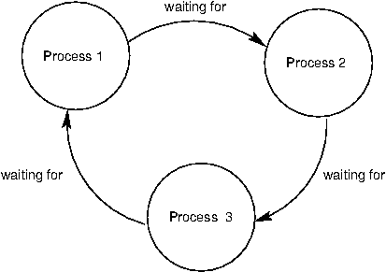

**SYSTEM ANALYSIS**

**EXISTING SYSTEM**

Sensitive data should be encrypted before outsourcing for privacy requirements, which obsoletes data utilization like keyword-based document retrieval The Cloud Service Providers (CSPs) that keep the data for users may access user’s sensitive information without authorization The existing techniques on keyword-based information retrieval which are widely used on the plaintext data, cannot be directly applied on the encrypted data The existing are not practical due to their high computational overhead for both the cloud sever and user Searchable Encryption (SE) schemes have made specific contributions in terms of efficiency, functionality and security.

**PROBLEM STATEMENT:**

* There are still many challenge problems in symmetric SE schemes
* High Computational Cost
* Server Performance Overhead
* Not an effective information retrieval
* Possibility to retrieve irrelevant information

**PROPOSED SYSTEM:**

In this project, we propose a secure tree-based search scheme over the encrypted cloud data, which supports multi-keyword ranked search and dynamic operation on the document collection. The proposed search scheme can flexibly achieve sub-linear search time and deal with the deletion and insertion of documents. The basic dynamic multi-keyword ranked search(BDMRS) scheme in the known cipher-text model The Enhanced Dynamic Multi-keyword Ranked Search (EDMRS) scheme in the Known background model The secure kNN algorithm is utilized to encrypt the index and query vectors, and mean while ensure accurate relevance score calculation between encrypted index and query vectors.

**ADVANTAGES OF PROPOSED SYSTEM:**

We design a searchable encryption scheme that supports both the accurate multi-keyword ranked search and flexible dynamic operation on document collection. Due to the special structure of our tree-based index, the search complexity of the proposed scheme is fundamentally kept to logarithmic. And in practice, the proposed scheme can achieve higher search efficiency by executing our “Greedy Depth-first Search” algorithm. Moreover, parallel search can be flexibly performed to further reduce the time cost of search process.

**SYSTEM STUDY**

**FEASIBILITY STUDY:**

The feasibility of the project is analyzed in this phase and business proposal is put forth with a very general plan for the project and some cost estimates. During system analysis the feasibility study of the proposed system is to be carried out. This is to ensure that the proposed system is not a burden to the company. For feasibility analysis, some understanding of the major requirements for the system is essential.

Three key considerations involved in the feasibility analysis are

* Economical feasibility
* Technical feasibility
* Social feasibility

**ECONOMICAL FEASIBILITY:**

This study is carried out to check the economic impact that the system will have on the organization. The amount of fund that the company can pour into the research and development of the system is limited. The expenditures must be justified. Thus the developed system as well within the budget and this was achieved because most of the technologies used are freely available. Only the customized products had to be purchased.

### TECHNICAL FEASIBILITY:

### This study is carried out to check the technical feasibility, that is, the technical requirements of the system. Any system developed must not have a high demand on the available technical resources. This will lead to high demands on the available technical resources. This will lead to high demands being placed on the client. The developed system must have a modest requirement, as only minimal or null changes are required for implementing this system.

**SOCIAL FEASIBILITY:**

The aspect of study is to check the level of acceptance of the system by the user. This includes the process of training the user to use the system efficiently. The user must not feel threatened by the system, instead must accept it as a necessity. The level of acceptance by the users solely depends on the methods that are employed to educate the user about the system and to make him familiar with it. His level of confidence must be raised so that he is also able to make some constructive criticism, which is welcomed, as he is the final user of the system.

**SYSTEM REQUIREMENT**

The purpose of system requirement specification is to produce the specification analysis of the task and also to establish complete information about the requirement, behavior and other constraints such as functional performance and so on. The goal of system requirement specification is to completely specify the technical requirements for the product in a concise and unambiguous manner.

**HARDWARE REQUIREMENTS:**

* System : Pentium IV 2.4 GHz.
* Hard Disk : 40 GB.
* Floppy Drive : 1.44 Mb.
* Monitor : 15 VGA Colour.
* Mouse : Intel.
* RAM : 512 Mb.

**SOFTWARE REQUIREMENTS:**

* Operating System : Windows 7/8
* Front End : Visual Studio 2010
* Back End : SQL Server 2008

5. **SOFTWARE ENVIRONMENT**

**.NET Framework**

The Microsoft .NET Framework (pronounced dot net) is a software framework developed by Microsoft that runs primarily on Microsoft Windows. It includes a large class library known as Framework Class Library (FCL) and provides language interoperability (each language can use code written in other languages) across several programming languages. Programs written for .NET Framework execute in a software environment (as contrasted to hardware environment), known as Common Language Runtime (CLR),an application virtual machine that provides services such as security, memory management, and exception handling. FCL and CLR together constitute .NET Framework.

FCL provides user interface, data access, database connectivity, cryptography, web application development, numeric algorithms, and network communications. Programmers produce software by combining their own source code with .NET Framework and other libraries. .NET Framework is intended to be used by most new applications created for Windows platform. Microsoft also produces an integrated development environment largely for .NET software called Visual Studio.

[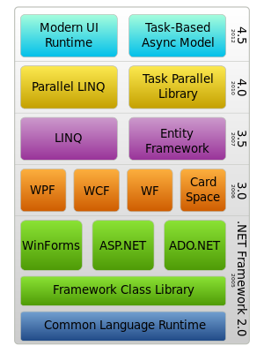](http://en.wikipedia.org/wiki/File:DotNet.svg)

**HISTORY**

Microsoft started development of .NET Framework in the late 1990s, originally under the name of Next Generation Windows Services (NGWS). By late 2000, the first beta versions of .NET 1.0 were released.

|  |  |  |  |  |  |  |
| --- | --- | --- | --- | --- | --- | --- |
| **OVERVIEW OF .NET FRAMEWORK RELEASE HISTORY** | | | | | | |
| Version number | CLR version | Release date | Included in | | | Replaces |
| Development tool | Windows | Windows Server |
| 1.0 | 1.0 | 2002-02-13 | Visual Studio .NET | N/A | N/A | N/A |
| 1.1 | 1.1 | 2003-04-24 | Visual Studio .NET 2003 | N/A | 2003 | 1.0 |
| 2.0 | 2.0 | 2005-11-07 | Visual Studio 2005 | N/A | 2003, 2003 R2, 2008 SP2, 2008 R2 SP1 | N/A |
| [3.0](http://en.wikipedia.org/wiki/.NET_Framework_version_history#.NET_Framework_3.0) | 2.0 | 2006-11-06 | [Expression Blend](http://en.wikipedia.org/wiki/Microsoft_Blend) | [Vista](http://en.wikipedia.org/wiki/Windows_Vista) | [2008 SP2](http://en.wikipedia.org/wiki/Windows_Server_2008_SP2), [2008 R2 SP1](http://en.wikipedia.org/wiki/Windows_Server_2008_R2_SP1) | 2.0 |
| [3.5](http://en.wikipedia.org/wiki/.NET_Framework_version_history#.NET_Framework_3.5) | 2.0 | 2007-11-19 | [Visual Studio 2008](http://en.wikipedia.org/wiki/Visual_Studio_2008) | [7](http://en.wikipedia.org/wiki/Windows_7), [8](http://en.wikipedia.org/wiki/Windows_8), [8.1](http://en.wikipedia.org/wiki/Windows_8.1) | [2008 R2 SP1](http://en.wikipedia.org/wiki/Windows_Server_2008_R2_SP1) | 2.0, 3.0 |
| [4.0](http://en.wikipedia.org/wiki/.NET_Framework_version_history#.NET_Framework_4) | 4 | 2010-04-12 | [Visual Studio 2010](http://en.wikipedia.org/wiki/Visual_Studio_2010) | N/A | N/A | N/A |
| [4.5](http://en.wikipedia.org/wiki/.NET_Framework_version_history#.NET_Framework_4.5) | 4 | 2012-08-15 | [Visual Studio 2012](http://en.wikipedia.org/wiki/Visual_Studio_2012) | [8](http://en.wikipedia.org/wiki/Windows_8) | [2012](http://en.wikipedia.org/wiki/Windows_Server_2012) | 4.0 |
| [4.5.1](http://en.wikipedia.org/wiki/.NET_Framework_version_history#.NET_Framework_4.5.1) | 4 | 2013-10-17 | [Visual Studio 2013](http://en.wikipedia.org/wiki/Visual_Studio_2013) | [8.1](http://en.wikipedia.org/wiki/Windows_8.1) | [2012 R2](http://en.wikipedia.org/wiki/Windows_Server_2012_R2) | 4.0, 4.5 |
| [4.5.2](http://en.wikipedia.org/wiki/.NET_Framework_version_history#.NET_Framework_4.5.2) | 4 | 2014-05-05 | N/A | N/A | N/A | 4.0, 4.5, 4.5.1 |

.NET Framework family also includes two versions for [mobile](http://en.wikipedia.org/wiki/Mobile_computing) or [embedded device](http://en.wikipedia.org/wiki/Embedded_device) use. A reduced version of the framework, [.NET Compact Framework](http://en.wikipedia.org/wiki/.NET_Compact_Framework), is available on [Windows CE](http://en.wikipedia.org/wiki/Windows_CE) platforms, including [Windows Mobile](http://en.wikipedia.org/wiki/Windows_Mobile) devices such as [smartphones](http://en.wikipedia.org/wiki/Smartphones" \o "Smartphones). Additionally, [.NET Micro Framework](http://en.wikipedia.org/wiki/.NET_Micro_Framework) is targeted at severely resource-constrained devices.

**ARCHITECTURE**

**COMMON LANGUAGE INFRASTRUCTURE:**

Common Language Runtime (CLI) provides a language-neutral platform for application development and execution, including functions for [exception handling](http://en.wikipedia.org/wiki/Exception_handling), [garbage collection](http://en.wikipedia.org/wiki/Garbage_collection_(computer_science)), security, and interoperability. By implementing the core aspects of .NET Framework within the scope of CLI, this functionality will not be tied to a single language but will be available across the many languages supported by the framework. Microsoft's implementation of CLI is [Common Language Runtime](http://en.wikipedia.org/wiki/Common_Language_Runtime) (CLR). It serves as the execution engine of .NET Framework. All .NET programs execute under the supervision of CLR, guaranteeing certain properties and behaviors in the areas of memory management, security, and exception handling.

For computer programs to run on CLI, they need to be compiled into [Common Intermediate Language](http://en.wikipedia.org/wiki/Common_Intermediate_Language) (CIL) – as opposed to being compiled into [machine code](http://en.wikipedia.org/wiki/Machine_code). Upon execution, an architecture-specific [Just-in-time compiler](http://en.wikipedia.org/wiki/Just-in-time_compilation) (JIT) turns the CIL code into machine code. To improve performance, however, .NET Framework comes with [Native Image Generator](http://en.wikipedia.org/wiki/Native_Image_Generator) (NGEN) that performs [ahead-of-time compilation](http://en.wikipedia.org/wiki/Ahead-of-time_compilation).

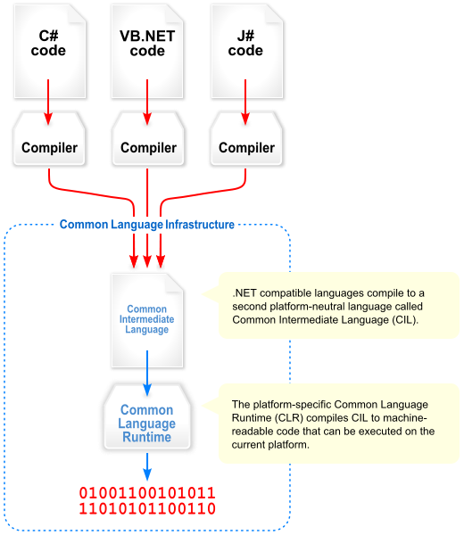

**Figure 2: visual overview of the common language infrastructure (CLI)**

**CLASS LIBRARY**

.NET Framework includes a set of [standard](http://en.wikipedia.org/wiki/Standard_library) class libraries. The class library is organized in a hierarchy of [namespaces](http://en.wikipedia.org/wiki/Namespaces). Most of the built-in APIs are part of either System.* or Microsoft.* namespaces. These class libraries implement a large number of common functions, such as file reading and writing, graphic rendering, database interaction, and XML document manipulation, among others. .NET class libraries are available to all [CLI compliant languages](http://en.wikipedia.org/wiki/List_of_CLI_languages). .NET Framework class library is divided into two parts: [Framework Class Library](http://en.wikipedia.org/wiki/Framework_Class_Library) (FCL) and [Base Class Library](http://en.wikipedia.org/wiki/Base_Class_Library) (BCL).

FCL includes a small subset of the entire class library and is the core set of classes that serve as the basic [API](http://en.wikipedia.org/wiki/API) of CLR. Classes in mscorlib.dll and some classes inSystem.dll and System.core.dll are part of FCL. FCL classes are available in .NET Framework as well as its alternative implementations including [.NET Compact Framework](http://en.wikipedia.org/wiki/.NET_Compact_Framework), [Microsoft Silverlight](http://en.wikipedia.org/wiki/Microsoft_Silverlight) and [Mono](http://en.wikipedia.org/wiki/Mono_(software)).

BCL is a superset of FCL and refers to the entire class library that ships with .NET Framework. It includes an expanded set of libraries, including [Windows Forms](http://en.wikipedia.org/wiki/Windows_Forms), [ADO.NET](http://en.wikipedia.org/wiki/ADO.NET),[ASP.NET](http://en.wikipedia.org/wiki/ASP.NET), [Language Integrated Query](http://en.wikipedia.org/wiki/Language_Integrated_Query) (LINQ), [Windows Presentation Foundation](http://en.wikipedia.org/wiki/Windows_Presentation_Foundation) (WPF), [Windows Communication Foundation](http://en.wikipedia.org/wiki/Windows_Communication_Foundation) (WCF) and [Workflow Foundation](http://en.wikipedia.org/wiki/Workflow_Foundation) (WF). BCL is much larger in scope than standard libraries for languages like [C++](http://en.wikipedia.org/wiki/C%2B%2B), and comparable in scope to [standard libraries of Java](http://en.wikipedia.org/wiki/Java_Class_Library).

**.NET CORE**

.NET Core is a [free and open-source](http://en.wikipedia.org/wiki/Free_and_open-source) partial implementation of the .NET Framework. It consists of CoreCLR and CoreFX, which are partial [forks](http://en.wikipedia.org/wiki/Fork_(software_development)) of CLR and BCL respectively.NET Core comes with an improved [JIT compiler](http://en.wikipedia.org/wiki/Just-in-time_compilation), called RyuJIT.

**ASSEMBLIES**

Compiled CIL code is stored in [CLI assemblies](http://en.wikipedia.org/wiki/Assembly_(CLI)). As mandated by the specification, assemblies are stored in [Portable Executable](http://en.wikipedia.org/wiki/Portable_Executable) (PE) file format, common on Windows platform for all [DLL](http://en.wikipedia.org/wiki/Dynamic-link_library) and [EXE](http://en.wikipedia.org/wiki/EXE) files. Each assembly consists of one or more files, one of which must contain a manifest bearing the [metadata](http://en.wikipedia.org/wiki/Metadata) for the assembly. The complete name of an assembly (not to be confused with the file name on disk) contains its simple text name, version number, culture, and [public key](http://en.wikipedia.org/wiki/Public_key) token. Assemblies are considered equivalent if they share the same complete name, excluding the revision of the version number. A private key can also be used by the creator of the assembly for [strong naming](http://en.wikipedia.org/wiki/Strong_name). The public key token identifies which private key an assembly is signed with. Only the creator of the keypair (typically .NET developer signing the assembly) can sign assemblies that have the same strong name as a previous version assembly, since the creator is in possession of the private key. Strong naming is required to add assemblies to [Global Assembly Cache](http://en.wikipedia.org/wiki/Global_Assembly_Cache).

**DESIGN TENETS**

**INTEROPERABILITY**

Because computer systems commonly require interaction between newer and older applications, .NET Framework provides means to access functionality implemented in newer and older programs that execute outside .NET environment. Access to [COM](http://en.wikipedia.org/wiki/Component_Object_Model) components is provided in System.Runtime.InteropServices andSystem.EnterpriseServices namespaces of the framework; access to other functionality is achieved using the [P/Invoke](http://en.wikipedia.org/wiki/Platform_Invocation_Services) feature.

**LANGUAGE INDEPENDENCE**

.NET Framework introduces a [Common Type System](http://en.wikipedia.org/wiki/Common_Type_System) (CTS) that defines all possible [datatypes](http://en.wikipedia.org/wiki/Datatypes" \o "Datatypes) and [programming](http://en.wikipedia.org/wiki/Programming_language) constructs supported by CLR and how they may or may not interact with each other conforming to CLI specification. Because of this feature, .NET Framework supports the exchange of types and object instances between libraries and applications written using [any conforming .NET language](http://en.wikipedia.org/wiki/List_of_CLI_languages).

**PORTABILITY**

While Microsoft has never implemented the full framework on any system except Microsoft Windows, it has engineered the framework to be platform-agnostic, and cross-platform implementations are available for other operating systems. Microsoft submitted the specifications for CLI (which includes the core class libraries, CTS, and CIL), and C++/CLI to both [ECMA](http://en.wikipedia.org/wiki/Ecma_International) and [ISO](http://en.wikipedia.org/wiki/International_Organization_for_Standardization), making them available as official standards. This makes it possible for third parties to create compatible implementations of the framework and its languages on other platforms.

**SECURITY**

.NET Framework has its own security mechanism with two general features: [Code Access Security](http://en.wikipedia.org/wiki/Code_Access_Security) (CAS), and validation and verification. CAS is based on evidence that is associated with a specific assembly. Typically the evidence is the source of the assembly (whether it is installed on the local machine or has been downloaded from the intranet or Internet). CAS uses evidence to determine the permissions granted to the code. Other code can demand that calling code be granted a specified permission. The demand causes CLR to perform a call stack walk: every assembly of each method in the call stack is checked for the required permission; if any assembly is not granted the permission a security exception is thrown.

**MEMORY MANAGEMENT**

CLR frees the developer from the burden of managing memory (allocating and freeing up when done); it handles memory management itself by detecting when memory can be safely freed. Instantiations of .NET types (objects) are allocated from the managed heap; a pool of memory managed by CLR. As long as there exists a reference to an object, which might be either a direct reference to an object or via a [graph](http://en.wikipedia.org/wiki/Graph_(data_structure)) of objects, the object is considered to be in use. When there is no reference to an object, and it cannot be reached or used, it becomes garbage, eligible for collection. .NET Framework includes a [garbage collector](http://en.wikipedia.org/wiki/Garbage_collection_(computer_science)) which runs periodically, on a separate [thread](http://en.wikipedia.org/wiki/Thread_(computing)) from the application's thread, that enumerates all the unusable objects and reclaims the memory allocated to them and this is more efficient then the java.

.NET [Garbage Collector](http://en.wikipedia.org/wiki/Garbage_collection_(computer_science)) (GC) is a non-deterministic, compacting, [mark-and-sweep](http://en.wikipedia.org/wiki/Tracing_garbage_collection#Na.C3.AFve_mark-and-sweep) garbage collector. GC runs only when a certain amount of memory has been used or there is enough pressure for memory on the system. Since it is not guaranteed when the conditions to reclaim memory are reached, GC runs are non-deterministic. Each .NET application has a set of roots, which are pointers to objects on the managed heap (managed objects). These include references to static objects and objects defined as local variables or method parameters currently in scope, as well as objects referred to by CPU registers. When GC runs, it pauses the application, and for each object referred to in the root, it [recursively](http://en.wikipedia.org/wiki/Recursion) enumerates all the objects reachable from the root objects and marks them as reachable. It uses CLI metadata and [reflection](http://en.wikipedia.org/wiki/Reflection_(computer_science)) to discover the objects encapsulated by an object, and then recursively walk them. It then enumerates all the objects on the heap (which were initially allocated contiguously) using reflection. All objects not marked as reachable are garbage. This is the mark phase. Since the memory held by garbage is not of any consequence, it is considered free space. However, this leaves chunks of free space between objects which were initially contiguous. The objects are then compacted together to make used memory contiguous again. Any reference to an object invalidated by moving the object is updated by GC to reflect the new location. The application is resumed after the garbage collection is over.

GC used by .NET Framework is also [generational](http://en.wikipedia.org/wiki/Garbage_collection_(computer_science)#Generational_GC_.28ephemeral_GC.29). Objects are assigned a generation; newly created objects belong to Generation 0. The objects that survive a garbage collection are tagged as Generation 1, and the Generation 1 objects that survive another collection are Generation 2 objects. .NET Framework uses up to Generation 2 objects. Higher generation objects are garbage collected less frequently than lower generation objects. This helps increase the efficiency of garbage collection, as older objects tend to have a longer lifetime than newer objects.  Thus, by eliminating older (and thus more likely to survive a collection) objects from the scope of a collection run, fewer objects need to be checked and compacted.

**SIMPLIFIED DEPLOYMENT**

.NET Framework includes design features and tools which help manage the installation of computer software to ensure that it does not interfere with previously installed software, and that it conforms to security requirements.

**STANDARDIZATION AND LICENSING**

**TIMELINE**

In August 2000, Microsoft, Hewlett-Packard, and Intel worked to standardize CLI and C#. By December 2001, both were ratified ECMA standards. The current version of ISO standards are ISO/IEC 23271:2012 and ISO/IEC 23270:2006.

While Microsoft and their partners hold patents for CLI and C#, ECMA and ISO require that all patents essential to implementation be made available under "reasonable and non-discriminatory terms". In addition to meeting these terms, the companies have agreed to make the patents available royalty-free. However, this did not apply for the part of .NET Framework not covered by ECMA/ISO standards, which included Windows Forms, ADO.NET, and ASP.NET. Patents that Microsoft holds in these areas may have deterred non-Microsoft implementations of the full framework.

On 3 October 2007, Microsoft announced that the source code for .NET Framework 3.5 libraries was to become available under the Microsoft Reference License (Ms-RSL).The source code repository became available online on 16 January 2008 and included BCL, ASP.NET, ADO.NET, Windows Forms, WPF and XML. Scott Guthrie of Microsoft promised LINQ, WCF and WF libraries were in process of being added.

On 12 November 2014, Microsoft announced .NET Core, in an effort to include cross-platform support for .NET, the source release of Microsoft's Core CLR implementation, source for the "entire [...] library stack" for .NET Core, and the adoption of a conventional ("bazaar"-like) open source development model under the stewardship of the .NET Foundation. Miguel de Icaza describes .NET Core as a "redesigned version of .NET that is based on the simplified version of the class libraries", and Microsoft's Immo Landwerth explained that .NET Core would be "the foundation of all future .NET platforms".

At the time of the announcement, the initial release of the .NET Core project had been seeded with a subset of the libraries' source code and coincided with the relicensing of Microsoft's existing .NET reference source away from the restrictions of the Microsoft Reference License. Both projects are made available under the MIT License. Landwerth acknowledged the disadvantages of the previously selected shared source license, explaining that it "made Rotor [the Microsoft reference implementation] a non-starter" as a community-developed open source project because it did not meet the criteria of an OSI-approved license.

Microsoft also produced an update to its patent grants, which further extends the scope beyond its previous pledges. Whereas before projects like Mono existed in a legal grey area because Microsoft's earlier grants applied only to the technology in "covered specifications", including strictly the 4th editions each of ECMA-334 and ECMA-335, the new patent promise places no ceiling on the specification version and even extends to any .NET runtime technologies documented on MSDN that haven't been formally specified by the ECMA group, if a project chooses to implement them. This permits Mono and other projects to maintain feature parity with modern .NET features that have been introduced since the 4th edition was published without being at risk of patent litigation over the implementation of those features. The new grant does maintain the restriction that any implementation must maintain minimum compliance with the mandatory parts of the CLI specification.

Microsoft's press release highlights that the cross-platform commitment now allows for a fully open source, modern server-side .NET stack. However, Microsoft does not plan to release the source for WPF or Windows Forms.

**LICENSING DETAILS**

|  |  |
| --- | --- |
| Component | License |
| .NET Core CoreFX and CoreCLR | MIT License |
| .NET Framework Micro | Apache License 2.0 |
| .NET Compiler Platform (codename "Roslyn") | Apache License 2.0 |
| ASP.NET | Apache License 2.0 |
| ASP.NET Web Stack | Apache License 2.0 |
| ASP.NET Ajax Control Toolkit | BSD License |
| ASP.NET SignalR | Apache License 2.0 |
| Entity Framework | Apache License 2.0 |
| NuGet | Apache License 2.0 |
| .NET Framework reference source code | Microsoft Reference License (Ms-RSL) |
| .NET Framework redistributable package | Proprietary software |

**Table: Components of .net framework**

**ALTERNATIVE IMPLEMENTATIONS**

.NET Framework is the predominant implementation of .NET technologies. Other implementations for parts of the framework exist. Although the runtime engine is described by an ECMA/ISO specification, other implementations of it may be encumbered by patent issues; ISO standards may include the disclaimer, "Attention is drawn to the possibility that some of the elements of this document may be the subject of patent rights. ISO shall not be held responsible for identifying any or all such patent rights." It is more difficult to develop alternatives to FCL, which is not described by an open standard and may be subject to copyright restrictions. Additionally, parts of FCL have Windows-specific functionality and behavior, so implementation on non-Windows platforms can be problematic. Some alternative implementations of parts of the framework are listed here.

.NET Micro Framework is a .NET platform for extremely resource-constrained devices. It includes a small version of CLR and supports development in C# (though some developers were able to use VB.NET, albeit with an amount of hacking, and with limited functionalities) and debugging (in an emulator or on hardware), both using Microsoft Visual Studio. It also features a subset of .NET Framework Class Library (about 70 classes with about 420 methods), a GUI framework loosely based on WPF, and additional libraries specific to embedded applications.

Mono is an implementation of CLI and FCL, and provides additional functionality. It is dual-licensed under free software and proprietary software licenses. It includes support for ASP.NET, ADO.NET, and Windows Forms libraries for a wide range of architectures and operating systems. It also includes C# and VB.NET compilers. Portable.NET (part of DotGNU) provides an implementation of CLI, portions of FCL, and a C# compiler. It supports a variety of CPUs and operating systems.Microsoft Shared Source Common Language Infrastructure is a non-free implementation of CLR. However, the last version only runs on Microsoft Windows XP SP2, and was not updated since 2006, therefore it does not contain all features of version 2.0 of .NET Framework. CrossNetis an implementation of CLI and portions of FCL. It is free software using the open source MIT License.

**PERFORMANCE**

The garbage collector, which is integrated into the environment, can introduce unanticipated delays of execution over which the developer has little direct control. "In large applications, the number of objects that the garbage collector needs to deal with can become very large, which means it can take a very long time to visit and rearrange all of them."

.NET Framework provides support for calling Streaming SIMD Extensions (SSE) via managed code from April 2014 in Visual Studio 2013 Update 2. However, Mono has provided support for SIMD Extensions as of version 2.2 within the Mono. SIMD namespace; before. Mono's lead developer Miguel de Icaza has expressed hope that this SIMD support will be adopted by CLR's ECMA standard. Streaming SIMD Extensions have been available in x86 CPUs since the introduction of the Pentium III. Some other architectures such as ARM and MIPS also have SIMD extensions. In case the CPU lacks support for those extensions, the instructions are simulated in software.

**SECURITY**

Unobfuscated managed CIL byte code can often be easier to reverse-engineer than native code. NET decompiler programs enable developers with no reverse-engineering skills to view the source code behind unobfuscated .NET assemblies (DLL/EXE). In contrast, applications built with Visual C++ are much harder to reverse-engineer and source code is almost never produced successfully, mainly due to compiler optimizations and lack of reflection. One concern is over possible loss of trade secrets and the bypassing of license control mechanisms. To mitigate this, Microsoft has included Dotfuscator Community Edition with Visual Studio .NET since 2002. Third-party obfuscation tools are also available from vendors such as vmware, V.i. Labs, Xenocode, Red Gate Software. Method-level encryption tools for .NET code are available from vendors such as SafeNet.

**Features of . Net:**

Microsoft .NET is a set of Microsoft software technologies for rapidly building and integrating XML Web services, Microsoft Windows-based applications, and Web solutions. The .NET Framework is a language-neutral platform for writing programs that can easily and securely interoperate. There’s no language barrier with .NET: there are numerous languages available to the developer including Managed C++, C#, Visual Basic and Java Script. The .NET framework provides the foundation for components to interact seamlessly, whether locally or remotely on different platforms. It standardizes common data types and communications protocols so that components created in different languages can easily interoperate.

“.NET” is also the collective name given to various software components built upon the .NET platform. These will be both products (Visual Studio.NET and Windows.NET Server, for instance) and services (like Passport, .NET My Services, and so on).

**THE .NET FRAMEWORK**

The .NET Framework has two main parts:

1. The Common Language Runtime (CLR).

2. A hierarchical set of class libraries.

The CLR is described as the “execution engine” of .NET. It provides the environment within which programs run. The most important features are

* Conversion from a low-level assembler-style language, called Intermediate Language (IL), into code native to the platform being executed on.
* Memory management, notably including garbage collection.
* Checking and enforcing security restrictions on the running code.
* Loading and executing programs, with version control and other such features.
* The following features of the .NET framework are also worth description:

**Managed Code**:

The code that targets .NET, and which contains certain extra Information- “metadata” - to describe itself. Whilst both managed and unmanaged code can run in the runtime, only managed code contains the information that allows the CLR to guarantee, for instance, safe execution and interoperability.

**Managed Data**

With Managed Code comes Managed Data. CLR provides memory allocation and Deal location facilities, and garbage collection. Some .NET languages use Managed Data by default, such as C#, Visual Basic.NET and JScript.NET, whereas others, namely C++, do not. Targeting CLR can, depending on the language you’re using, impose certain constraints on the features available. As with managed and unmanaged code, one can have both managed and unmanaged data in .NET applications - data that doesn’t get garbage collected but instead is looked after by unmanaged code.

**Common Type System**

The CLR uses something called the Common Type System (CTS) to strictly enforce type-safety. This ensures that all classes are compatible with each other, by describing types in a common way. CTS define how types work within the runtime, which enables types in one language to interoperate with types in another language, including cross-language exception handling. As well as ensuring that types are only used in appropriate ways, the runtime also ensures that code doesn’t attempt to access memory that hasn’t been allocated to it.

**Common Language Specification**

The CLR provides built-in support for language interoperability. To ensure that you can develop managed code that can be fully used by developers using any programming language, a set of language features and rules for using them called the Common Language Specification (CLS) has been defined. Components that follow these rules and expose only CLS features are considered CLS-compliant.

**THE CLASS LIBRARY**

.NET provides a single-rooted hierarchy of classes, containing over 7000 types. The root of the namespace is called System; this contains basic types like Byte, Double, Boolean, and String, as well as Object. All objects derive from System. Object. As well as objects, there are value types. Value types can be allocated on the stack, which can provide useful flexibility. There are also efficient means of converting value types to object types if and when necessary.

The set of classes is pretty comprehensive, providing collections, file, screen, and network I/O, threading, and so on, as well as XML and database connectivity.

The class library is subdivided into a number of sets (or namespaces), each providing distinct areas of functionality, with dependencies between the namespaces kept to a minimum.

**LANGUAGES SUPPORTED BY .NET**

The multi-language capability of the .NET Framework and Visual Studio .NET enables developers to use their existing programming skills to build all types of applications and XML Web services. The .NET framework supports new versions of Microsoft’s old favorites Visual Basic and C++ (as VB.NET and Managed C++), but there are also a number of new additions to the family.

Visual Basic .NET has been updated to include many new and improved language features that make it a powerful object-oriented programming language. These features include inheritance, interfaces, and overloading, among others. Visual Basic also now supports structured exception handling, custom attributes and also supports multi-threading.

Visual Basic .NET is also CLS compliant, which means that any CLS-compliant language can use the classes, objects, and components you create in Visual Basic .NET.

Managed Extensions for C++ and attributed programming are just some of the enhancements made to the C++ language. Managed Extensions simplify the task of migrating existing C++ applications to the new .NET Framework.

C# is Microsoft’s new language. It’s a C-style language that is essentially “C++ for Rapid Application Development”. Unlike other languages, its specification is just the grammar of the language. It has no standard library of its own, and instead has been designed with the intention of using the .NET libraries as its own.

Microsoft Visual J# .NET provides the easiest transition for Java-language developers into the world of XML Web Services and dramatically improves the interoperability of Java-language programs with existing software written in a variety of other programming languages.

Active State has created Visual Perl and Visual Python, which enable .NET-aware applications to be built in either Perl or Python. Both products can be integrated into the Visual Studio .NET environment. Visual Perl includes support for Active State’s Perl Dev Kit. Other languages for which .NET compilers are available include

* FORTRAN
* COBOL
* Eiffel

C#.NET is also compliant with CLS (Common Language Specification) and supports structured exception handling. CLS is set of rules and constructs that are supported by the CLR (Common Language Runtime). CLR is the runtime environment provided by the .NET Framework; it manages the execution of the code and also makes the development process easier by providing services.

C#.NET is a CLS-compliant language. Any objects, classes, or components that created in C#.NET can be used in any other CLS-compliant language. In addition, we can use objects, classes, and components created in other CLS-compliant languages in C#.NET .The use of CLS ensures complete interoperability among applications, regardless of the languages used to create the application.

**CONSTRUCTORS AND DESTRUCTORS:**

Constructors are used to initialize objects, whereas destructors are used to destroy them. In other words, destructors are used to release the resources allocated to the object. In C#.NET the sub finalize procedure is available. The sub finalize procedure is used to complete the tasks that must be performed when an object is destroyed. The sub finalize procedure is called automatically when an object is destroyed. In addition, the sub finalize procedure can be called only from the class it belongs to or from derived classes.

**GARBAGE COLLECTION**

Garbage Collection is another new feature in C#.NET. The .NET Framework monitors allocated resources, such as objects and variables. In addition, the .NET Framework automatically releases memory for reuse by destroying objects that are no longer in use.

In C#.NET, the garbage collector checks for the objects that are not currently in use by applications. When the garbage collector comes across an object that is marked for garbage collection, it releases the memory occupied by the object.

**OVERLOADING**

Overloading is another feature in C#. Overloading enables us to define multiple procedures with the same name, where each procedure has a different set of arguments. Besides using overloading for procedures, we can use it for constructors and properties in a class.

**MULTITHREADING:**

C#.NET also supports multithreading. An application that supports multithreading can handle multiple tasks simultaneously, we can use multithreading to decrease the time taken by an application to respond to user interaction.

**STRUCTURED EXCEPTION HANDLING**

C#.NET supports structured handling, which enables us to detect and remove errors at runtime. In C#.NET, we need to use Try…Catch…Finally statements to create exception handlers. Using Try…Catch…Finally statements, we can create robust and effective exception handlers to improve the performance of our application.

**THE .NET FRAMEWORK**

The .NET Framework is a new computing platform that simplifies application development in the highly distributed environment of the Internet.

**OBJECTIVES OF. NET FRAMEWORK**

1. To provide a consistent object-oriented programming environment whether object codes is stored and executed locally on Internet-distributed, or executed remotely.

2. To provide a code-execution environment to minimizes software deployment and guarantees safe execution of code.

3. Eliminates the performance problems.

There are different types of application, such as Windows-based applications and Web-based applications.

**MICROSOFT SQL SERVER**

**Microsoft SQL Server** is a [relational database management system](http://en.wikipedia.org/wiki/Relational_database_management_system) developed by [Microsoft](http://en.wikipedia.org/wiki/Microsoft). As a database, it is a software product whose primary function is to store and retrieve data as requested by other software applications, be it those on the same computer or those running on another computer across a network (including the Internet). There are at least a dozen different editions of Microsoft SQL Server aimed at different audiences and for workloads ranging from small single-machine applications to large Internet-facing applications with many [concurrent users](http://en.wikipedia.org/wiki/Concurrent_user). Its primary [query languages](http://en.wikipedia.org/wiki/Query_language) are [T-SQL](http://en.wikipedia.org/wiki/Transact-SQL) and [ANSI SQL](http://en.wikipedia.org/wiki/SQL).

**HISTORY:**

**GENESIS**

Prior to version 7.0 the [code base](http://en.wikipedia.org/wiki/Code_base) for MS SQL Server was sold by [Sybase SQL Server](http://en.wikipedia.org/wiki/Sybase_SQL_Server) to Microsoft, and was Microsoft's entry to the enterprise-level database market, competing against [Oracle](http://en.wikipedia.org/wiki/Oracle_database), [IBM](http://en.wikipedia.org/wiki/IBM), and, later, [Sybase](http://en.wikipedia.org/wiki/Sybase). Microsoft, Sybase and [Ashton-Tate](http://en.wikipedia.org/wiki/Ashton-Tate) originally worked together to create and market the first version named SQL Server 1.0 for [OS/2](http://en.wikipedia.org/wiki/OS/2) (about 1989) which was essentially the same as Sybase SQL Server 3.0 on [Unix](http://en.wikipedia.org/wiki/Unix" \o "Unix),[VMS](http://en.wikipedia.org/wiki/Virtual_Memory_System), etc. Microsoft SQL Server 4.2 was shipped around 1992 (available bundled with IBM [OS/2](http://en.wikipedia.org/wiki/OS/2) version 1.3). Later Microsoft SQL Server 4.21 for [Windows NT](http://en.wikipedia.org/wiki/Windows_NT) was released at the same time as Windows NT 3.1. Microsoft SQL Server v6.0 was the first version designed for NT, and did not include any direction from[Sybase](http://en.wikipedia.org/wiki/Sybase).

About the time [Windows NT](http://en.wikipedia.org/wiki/Windows_NT) was released in July 1993, Sybase and Microsoft parted ways and each pursued its own design and marketing schemes. Microsoft negotiated exclusive rights to all versions of SQL Server written for Microsoft operating systems. Until 1994, Microsoft's SQL Server carried three Sybase copyright notices as an indication of its origin.

SQL Server 7.0 and SQL Server 2000 included modifications and extensions to the Sybase code base, adding support for the [IA-64](http://en.wikipedia.org/wiki/IA-64) architecture. By SQL Server 2005 the legacy Sybase code had been completely rewritten.

Since the release of SQL Server 2000, advances have been made in performance, the client IDE tools, and several complementary systems that are packaged with SQL Server 2005. These include:

* an [extract-transform-load (ETL)](http://en.wikipedia.org/wiki/Extract,_transform,_load) tool (SQL Server Integration Services or [SSIS](http://en.wikipedia.org/wiki/SQL_Server_Integration_Services))
* a [Reporting Server](http://en.wikipedia.org/wiki/SQL_Server_Reporting_Services)
* an [OLAP](http://en.wikipedia.org/wiki/OLAP) and [data mining](http://en.wikipedia.org/wiki/Data_mining) server ([Analysis Services](http://en.wikipedia.org/wiki/Microsoft_Analysis_Services))
* several messaging technologies, specifically Service Broker and Notification Services

|  |  |  |  |  |
| --- | --- | --- | --- | --- |
| **SQL SERVER RELEASE HISTORY** | | | | |
| **Version** | **Year** | **Release Name** | **Codename** | **Internal Version** |
| 1.0 ([OS/2](http://en.wikipedia.org/wiki/OS/2)) | 1989 | SQL Server 1.0 (16 bit) | Ashton-Tate / Microsoft SQL Server | - |
| 1.1 ([OS/2](http://en.wikipedia.org/wiki/OS/2)) | 1991 | SQL Server 1.1 (16 bit) | - | - |
| 4.21 ([WinNT](http://en.wikipedia.org/wiki/Windows_NT)) | 1993 | SQL Server 4.21 | SQLNT | - |
| 6.0 | 1995 | SQL Server 6.0 | SQL95 | - |
| 6.5 | 1996 | SQL Server 6.5 | Hydra | - |
| 7.0 | 1998 | SQL Server 7.0 | Sphinx | 515 |
| - | 1999 | SQL Server 7.0 [OLAP](http://en.wikipedia.org/wiki/OLAP) Tools | Palato mania | - |
| 8.0 | 2000 | SQL Server 2000 | Shiloh | 539 |
| 8.0 | 2003 | SQL Server 2000 64-bit Edition | Liberty | 539 |
| 9.0 | 2005 | SQL Server 2005 | Yukon | 611/612 |
| 10.0 | 2008 | SQL Server 2008 | Katmai | 661 |
| 10.25 | 2010 | Azure SQL DB | Matrix (aka CloudDatabase or CloudDB) | - |
| 10.50 | 2010 | SQL Server 2008 R2 | Kilimanjaro (aka KJ) | 665 |
| 11.0 | 2012 | SQL Server 2012 | Denali | 706 |
| 12.0 | 2014 | SQL Server 2014 | SQL14 | 782 |

**SQL SERVER 2005:**

SQL Server 2005 (formerly codenamed "Yukon") released in October 2005. It included native support for managing [XML](http://en.wikipedia.org/wiki/XML) data, in addition to [relational data](http://en.wikipedia.org/wiki/Relational_database). For this purpose, it defined an xml [data type](http://en.wikipedia.org/wiki/Data_type) that could be used either as a data type in database columns or as [literals](http://en.wikipedia.org/wiki/Literal_(computer_science)) in queries. XML columns can be associated with [XSD](http://en.wikipedia.org/wiki/XSD) schemas; XML data being stored is verified against the schema. XML is converted to an internal binary data type before being stored in the database. Specialized indexing methods were made available for XML data. XML data is queried using [XQuery](http://en.wikipedia.org/wiki/XQuery" \o "XQuery); SQL Server 2005 added some extensions to the [T-SQL](http://en.wikipedia.org/wiki/T-SQL) language to allow embedding XQuery queries in T-SQL. In addition, it also defines a new extension to XQuery, called XML DML, that allows query-based modifications to XML data. SQL Server 2005 also allows a database server to be exposed over [web services](http://en.wikipedia.org/wiki/Web_service) using [Tabular Data Stream](http://en.wikipedia.org/wiki/Tabular_Data_Stream) (TDS) packets encapsulated within [SOAP (protocol)](http://en.wikipedia.org/wiki/SOAP_(protocol)) requests. When the data is accessed over web services, results are returned as XML.

[Common Language Runtime](http://en.wikipedia.org/wiki/Common_Language_Runtime) (CLR) integration was introduced with this version, enabling one to write SQL code as Managed Code by the CLR. For relational data, [T-SQL](http://en.wikipedia.org/wiki/T-SQL) has been augmented with error handling features (try/catch) and support for recursive queries with CTEs (Common Table Expressions). SQL Server 2005 has also been enhanced with new indexing algorithms, syntax and better error recovery systems. Data pages are [checksummed](http://en.wikipedia.org/wiki/Checksum" \o "Checksum) for better error resiliency, and optimistic concurrency support has been added for better performance. Permissions and access control have been made more granular and the query processor handles concurrent execution of queries in a more efficient way. Partitions on tables and indexes are supported natively, so scaling out a database onto a [cluster](http://en.wikipedia.org/wiki/Cluster_(computing)) is easier. SQL CLR was introduced with SQL Server 2005 to let it integrate with the .NET Framework.

SQL Server 2005 introduced Multi-Version Concurrency Control. User facing features include new transaction isolation level called SNAPSHOT and a variation of the READ COMMITTED isolation level based on statement-level data snapshots.SQL Server 2005 introduced "MARS" (Multiple Active Results Sets), a method of allowing usage of [database connections](http://en.wikipedia.org/wiki/Database_connection) for multiple purposes. SQL Server 2005 introduced DMVs (Dynamic Management Views), which are specialized views and functions that return server state information that can be used to monitor the health of a server instance, diagnose problems, and tune performance. Service Pack 1 (SP1) of SQL Server 2005 introduced Database Mirroring, a high availability option that provides redundancy and failover capabilities at the database level. Failover can be performed manually or can be configured for automatic failover. Automatic failover requires a witness partner and an operating mode of synchronous (also known as high-safety or full safety).

**ARCHITECTURE:**

The protocol layer implements the external interface to SQL Server. All operations that can be invoked on SQL Server are communicated to it via a Microsoft-defined format, called [Tabular Data Stream](http://en.wikipedia.org/wiki/Tabular_Data_Stream) (TDS). TDS is an application layer protocol, used to transfer data between a database server and a client. Initially designed and developed by Sybase Inc. for their [Sybase SQL Server](http://en.wikipedia.org/wiki/Sybase_SQL_Server) relational database engine in 1984, and later by Microsoft in Microsoft SQL Server, TDS packets can be encased in other physical transport dependent protocols, including [TCP/IP](http://en.wikipedia.org/wiki/TCP/IP), [Named pipes](http://en.wikipedia.org/wiki/Named_pipe), and [Shared memory](http://en.wikipedia.org/wiki/Shared_memory). Consequently, access to SQL Server is available over these protocols. In addition, the SQL Server API is also exposed over [web services](http://en.wikipedia.org/wiki/Web_service)

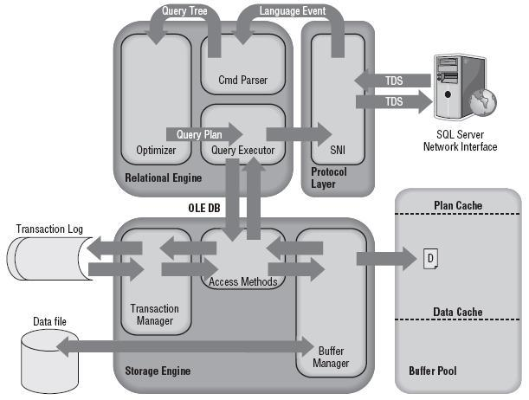

**FEATURES SQL SERVER:**

The OLAP Services feature available in SQL Server version 7.0 is now called SQL Server 2000 Analysis Services. The term OLAP Services has been replaced with the term Analysis Services. Analysis Services also includes a new data mining component. The Repository component available in SQL Server version 7.0 is now called Microsoft SQL Server 2000 Meta Data Services. References to the component now use the term Meta Data Services. The term repository is used only in reference to the repository engine within Meta Data Services

SQL-SERVER database consist of six type of objects,

They are,

1. TABLE

2. QUERY

3. FORM

4. REPORT

5. MACRO

**TABLE:**

A database is a collection of data about a specific topic.

**VIEWS OF TABLE:**

We can work with a table in two types,

1. Design View

2. Datasheet View

**Design View**

To build or modify the structure of a table we work in the table design view. We can specify what kind of data will be hold.

**Datasheet View**

To add, edit or analyses the data itself we work in tables datasheet view mode.

**QUERY:**

A query is a question that has to be asked the data. Access gathers data that answers the question from one or more table. The data that make up the answer is either dynaset (if you edit it) or a snapshot (it cannot be edited).Each time we run query, we get latest information in the dynaset. Access either displays the dynaset or snapshot for us to view or perform an action on it, such as deleting or updating.

**SYSTEM DESIGN**

**ARCHITECTURE DIAGRAM:**

System architecture is a conceptual model that defines the structure, behaviour, and more views of a system. An architecture description is a formal description and representation of a system, organized in a way that supports reasoning about the structures and behaviours of the system.



**UML DIAGRAMS**

UML stands for Unified Modeling Language. UML is a standardized general-purpose modeling language in the field of object-oriented software engineering. The standard is managed, and was created by, the Object Management Group.

The goal is for UML to become a common language for creating models of object oriented computer software. In its current form UML is comprised of two major components: a Meta-model and a notation. In the future, some form of method or process may also be added to; or associated with, UML.

The Unified Modeling Language is a standard language for specifying, Visualization, Constructing and documenting the artifacts of software system, as well as for business modeling and other non-software systems.

The UML represents a collection of best engineering practices that have proven successful in the modeling of large and complex systems.

The UML is a very important part of developing objects oriented software and the software development process. The UML uses mostly graphical notations to express the design of software projects.

**GOALS:**

The Primary goals in the design of the UML are as follows:

1. Provide users a ready-to-use, expressive visual modeling Language so that they can develop and exchange meaningful models.
2. Provide extendibility and specialization mechanisms to extend the core concepts.
3. Be independent of particular programming languages and development process.
4. Provide a formal basis for understanding the modeling language.
5. Encourage the growth of OO tools market.
6. Support higher level development concepts such as collaborations, frameworks, patterns and components.
7. Integrate best practices.

**USE CASE DIAGRAM:**

A use case diagram in the Unified Modeling Language (UML) is a type of behavioral diagram defined by and created from a Use-case analysis. Its purpose is to present a graphical overview of the functionality provided by a system in terms of actors, their goals (represented as use cases), and any dependencies between those use cases. The main purpose of a use case diagram is to show what system functions are performed for which actor. Roles of the actors in the system can be depicted.



**CLASS DIAGRAM:**

In software engineering, a class diagram in the Unified Modeling Language (UML) is a type of static structure diagram that describes the structure of a system by showing the system's classes, their attributes, operations (or methods), and the relationships among the classes. It explains which class contains information.



**SEQUENCE DIAGRAM:**

A sequence diagram in Unified Modeling Language (UML) is a kind of interaction diagram that shows how processes operate with one another and in what order. It is a construct of a Message Sequence Chart. Sequence diagrams are sometimes called event diagrams, event scenarios, and timing diagrams.



**COLLABORATION DIAGRAM**



**ACTIVITY DIAGRAM:**

Activity diagrams are graphical representations of workflows of stepwise activities and actions with support for choice, iteration and concurrency. In the Unified Modeling Language, activity diagrams can be used to describe the business and operational step-by-step workflows of components in a system. An activity diagram shows the overall flow of control.



**SCREEN SHOT**

**Home Page:**

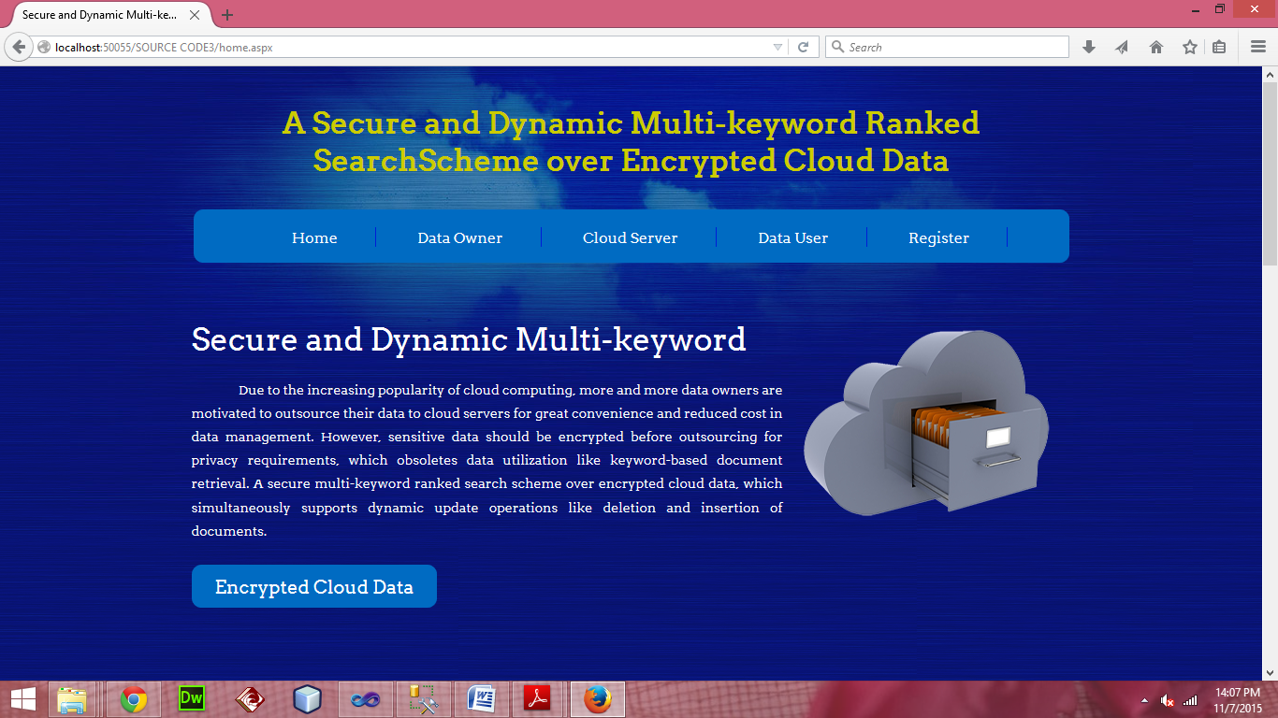

**User Registeration:**

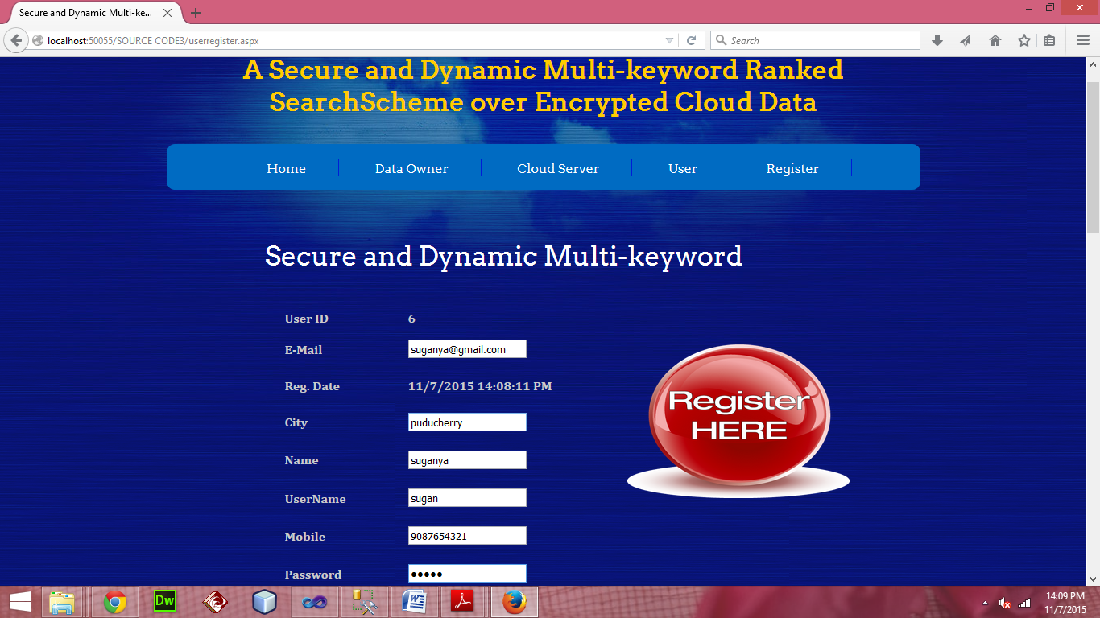

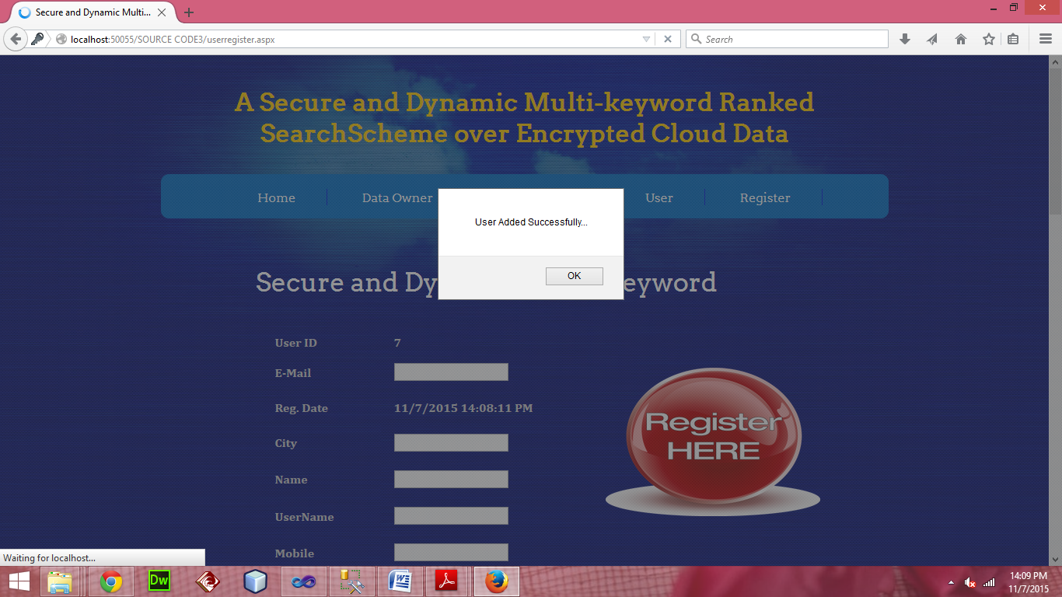

**User Login:**

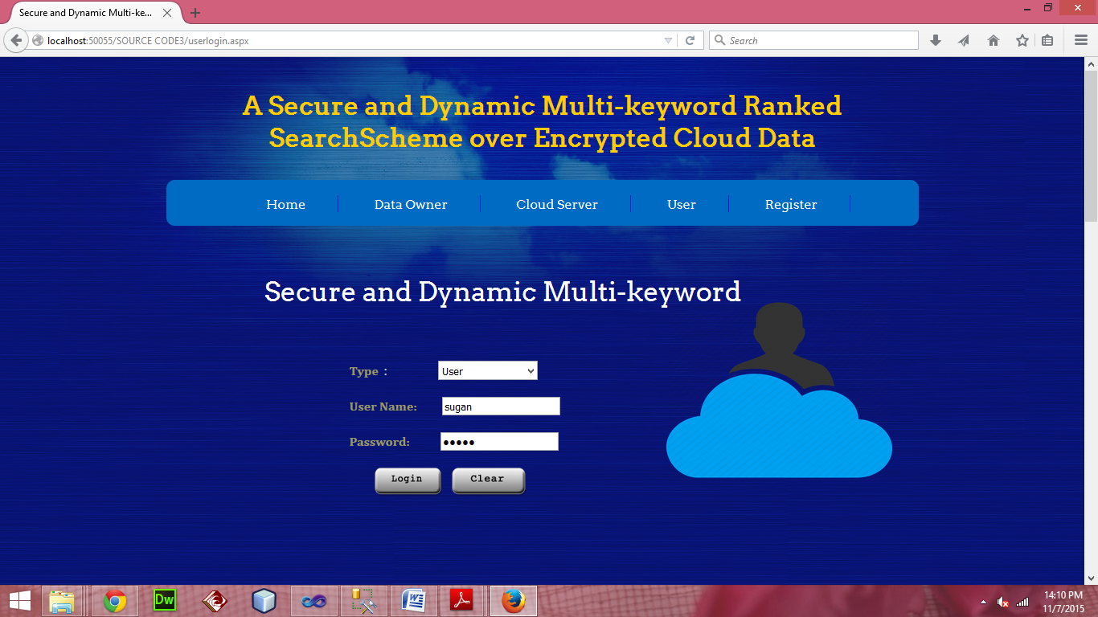

**User Home Page:**

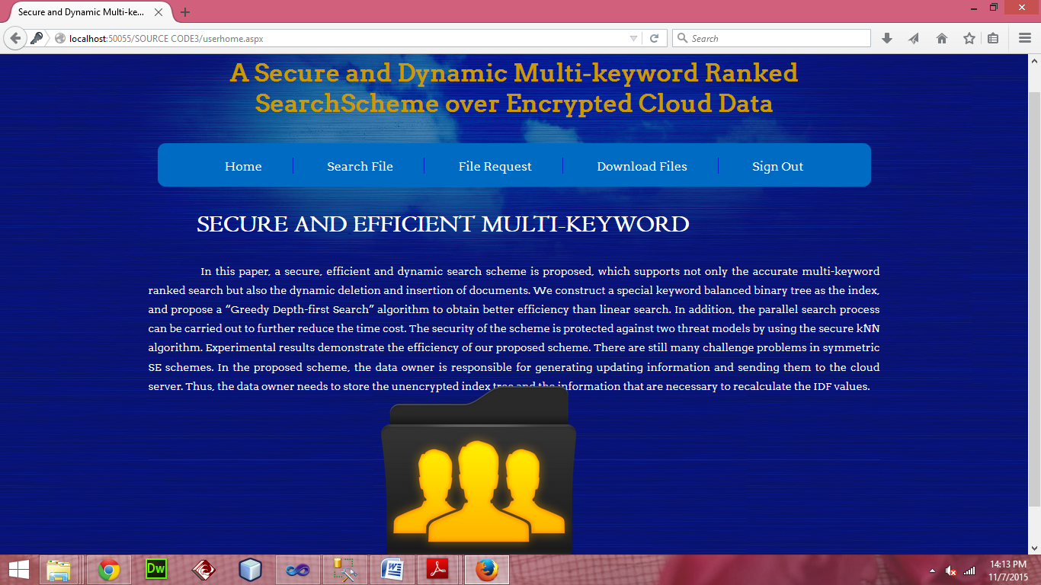

**SEARCH FILE – KEYWORD SEARCH:**

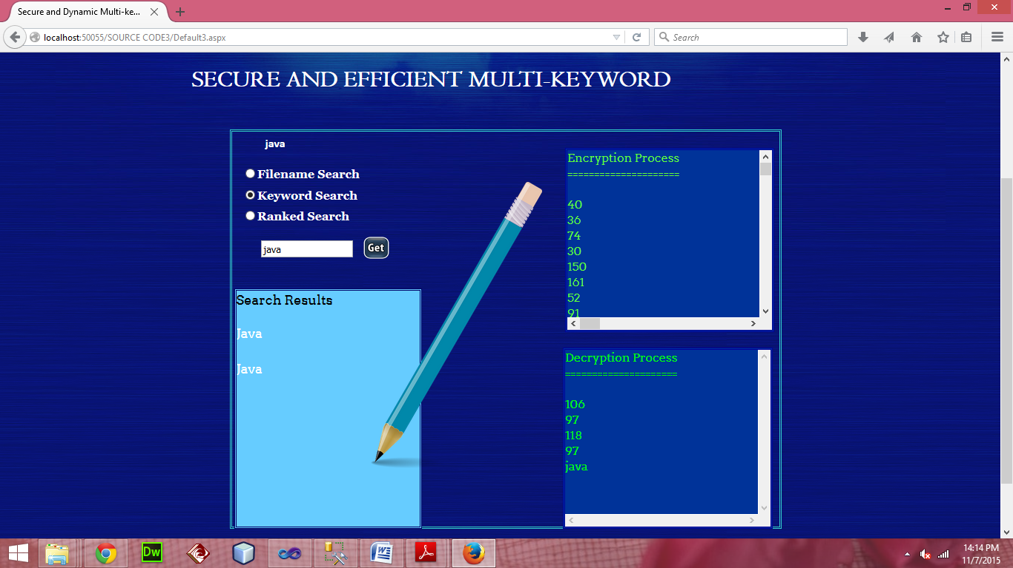

**SEARCH FILES – RANKED SEARCH**

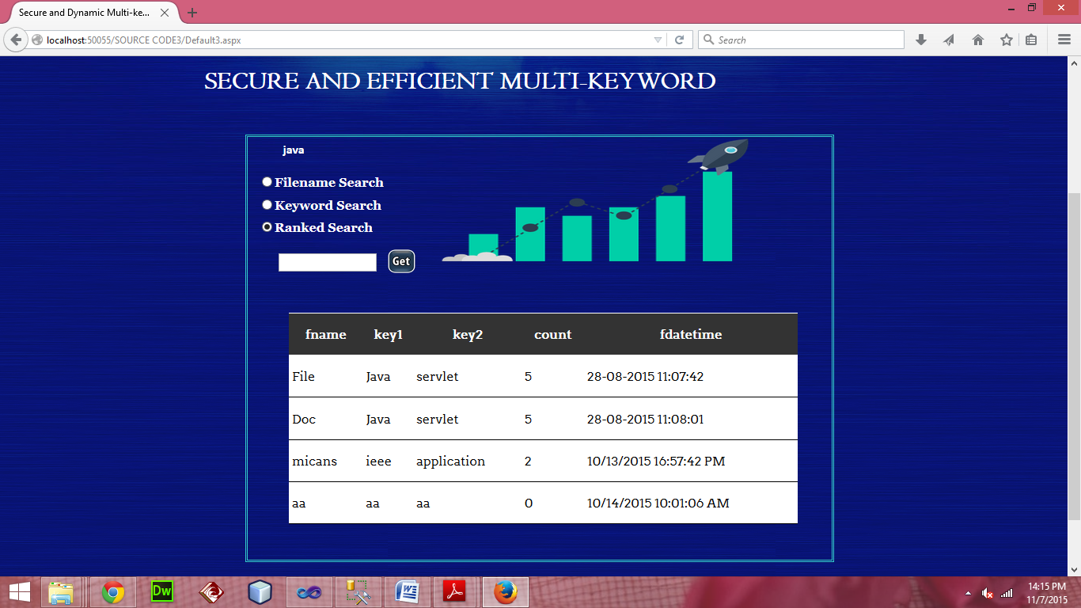

**SEARCH FILE – FILE SEARCH**

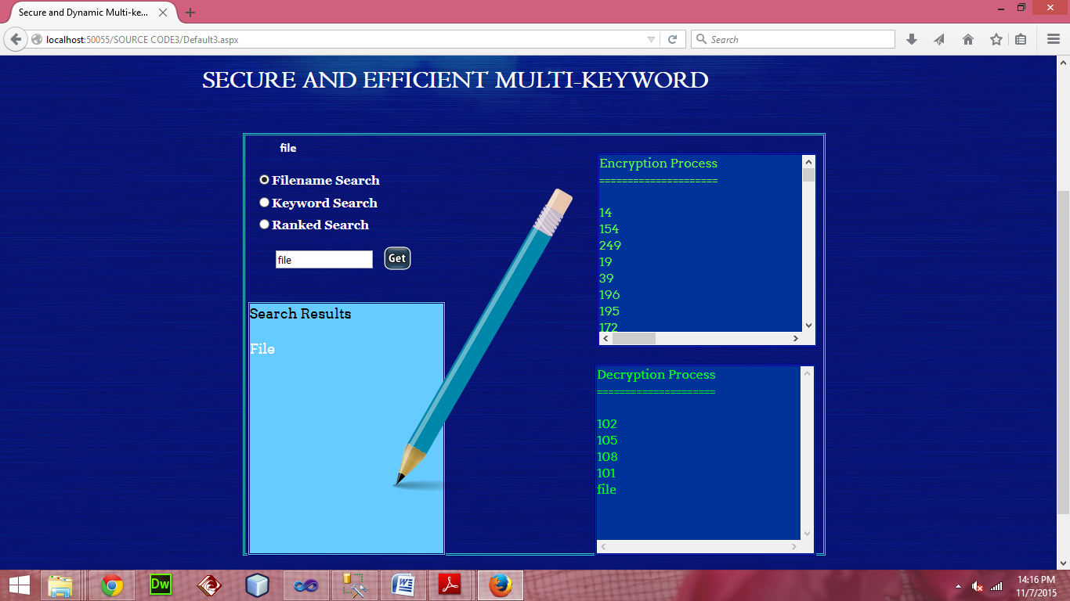

**FILE REQUEST:**

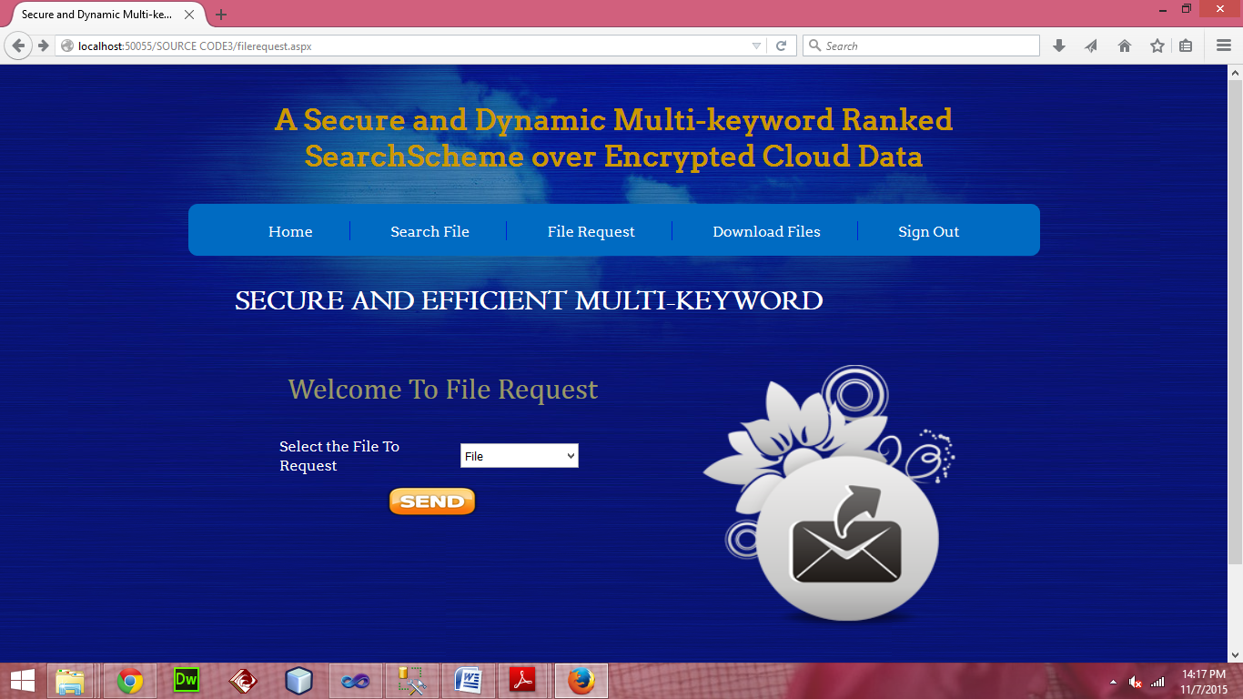

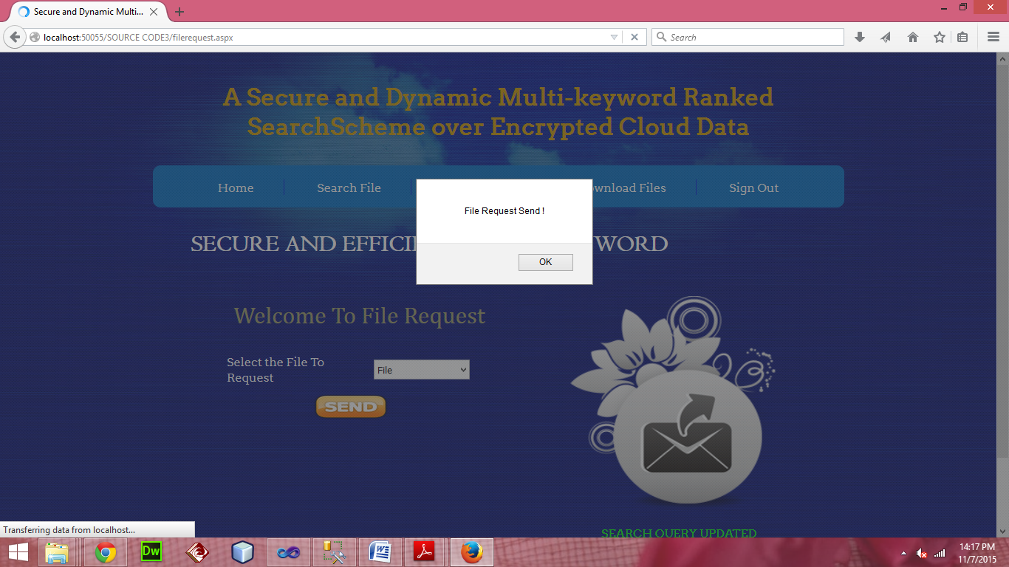

**DOWNLOAD FILES:**

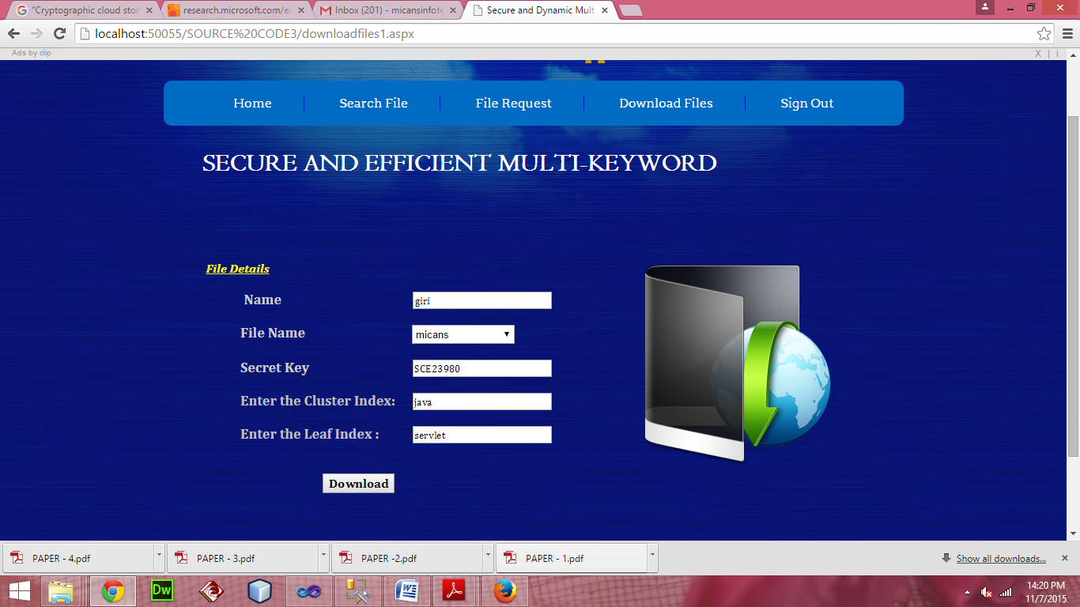

**CLOUD LOGIN:**

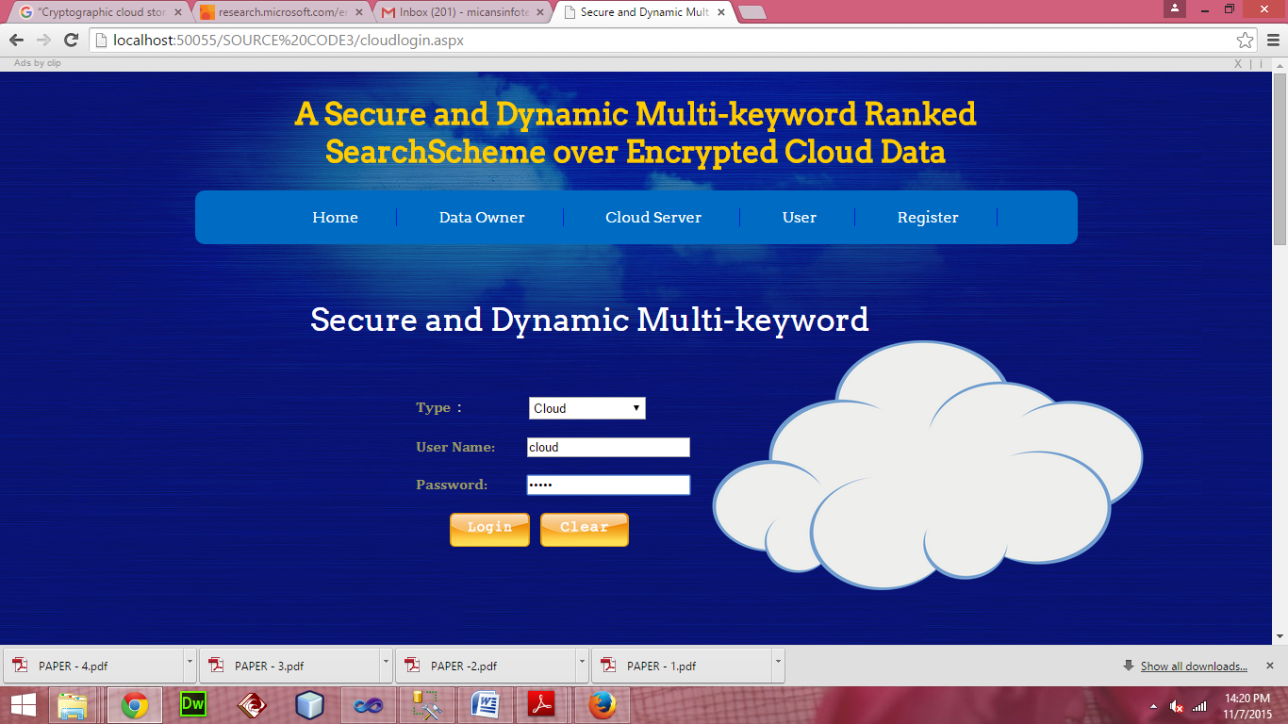

**FILE DETAILS:**

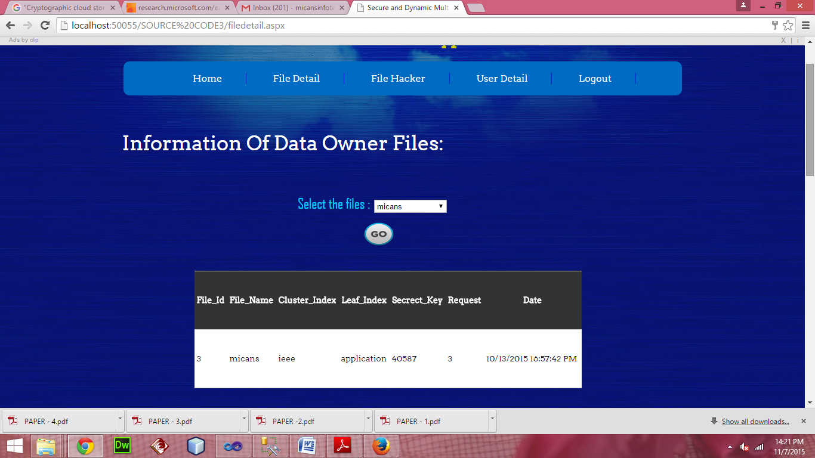

**HACKER DETAILS:**

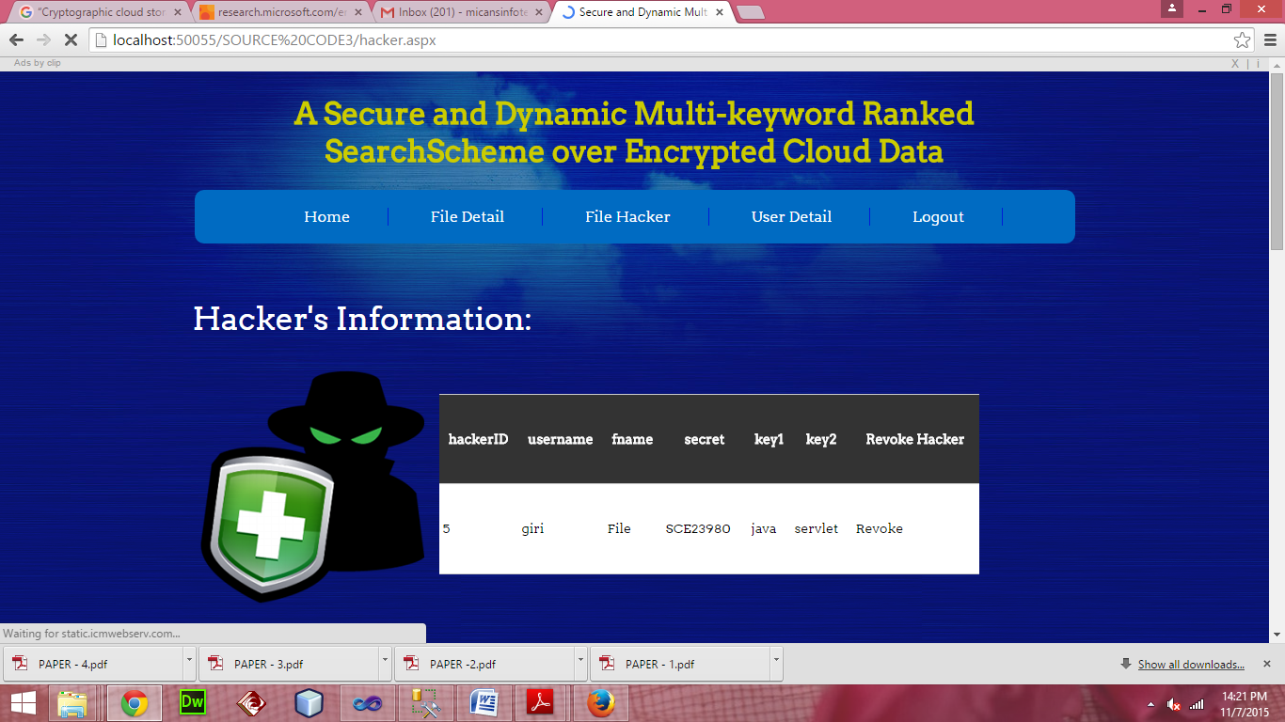

**USER DETAILS:**

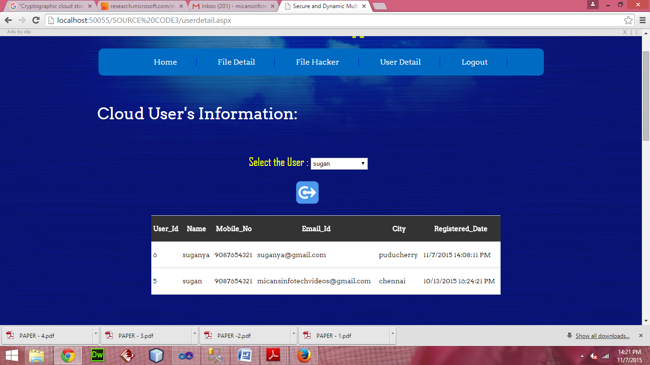

**OWNER LOGIN:**

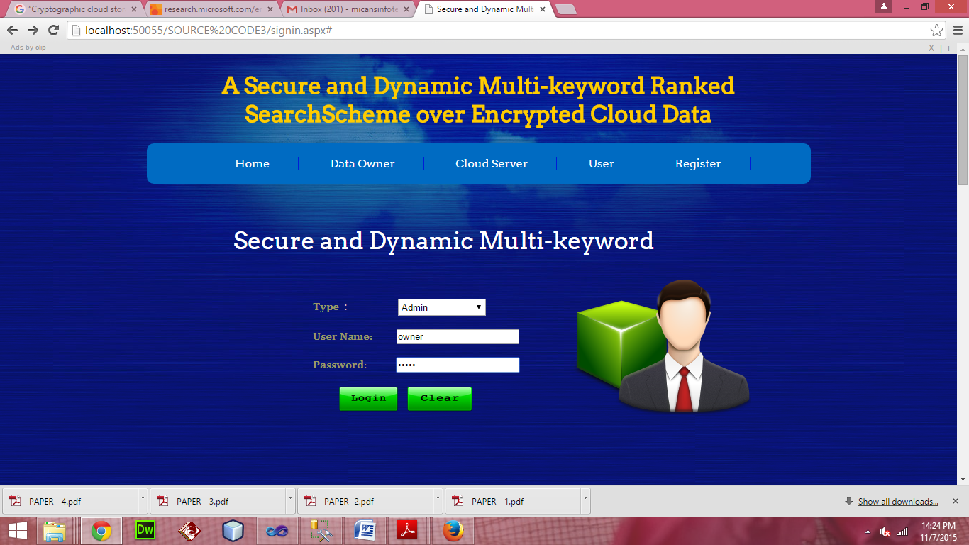

**UPLOAD FILE:**

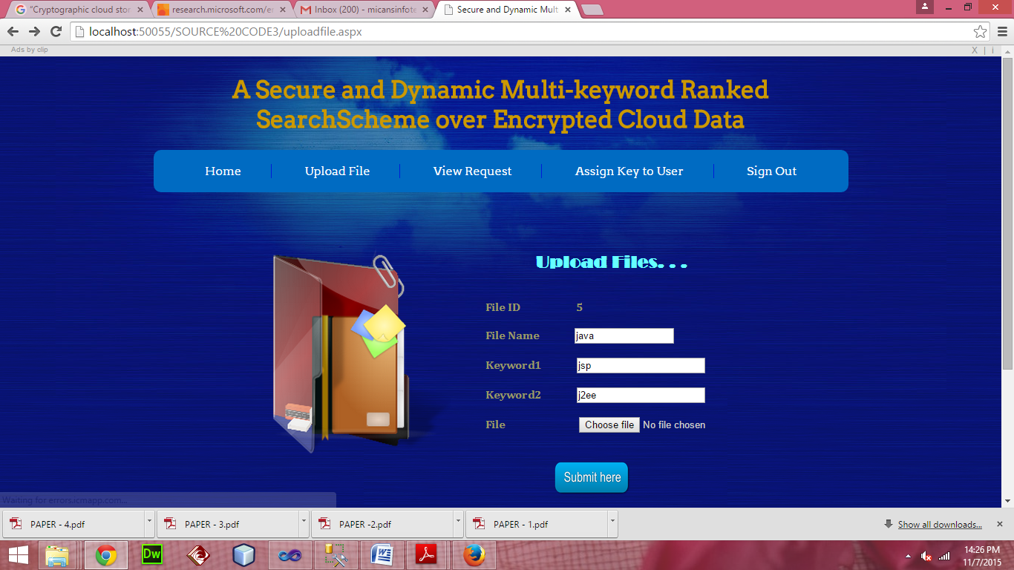

**USER FILE REQUEST:**

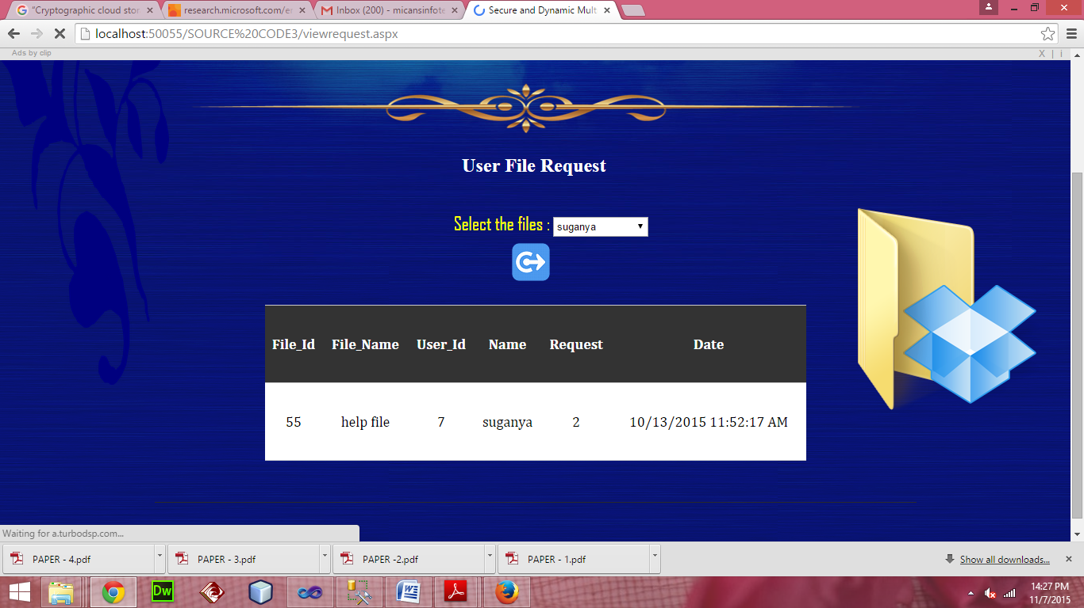

**KEY GENERATION:**

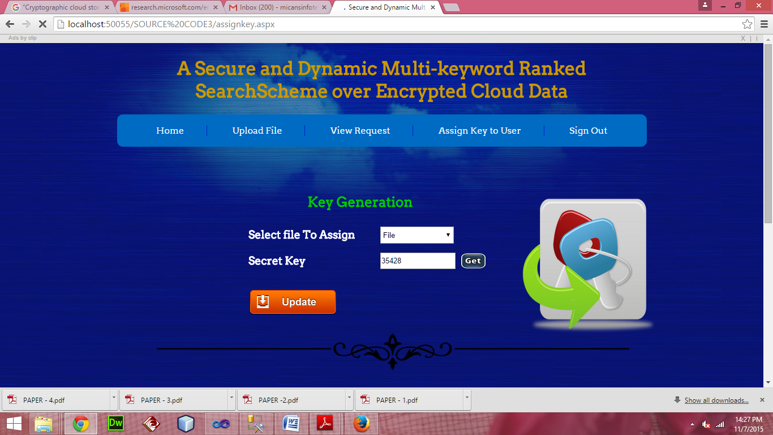

**SEND REQUEST:**

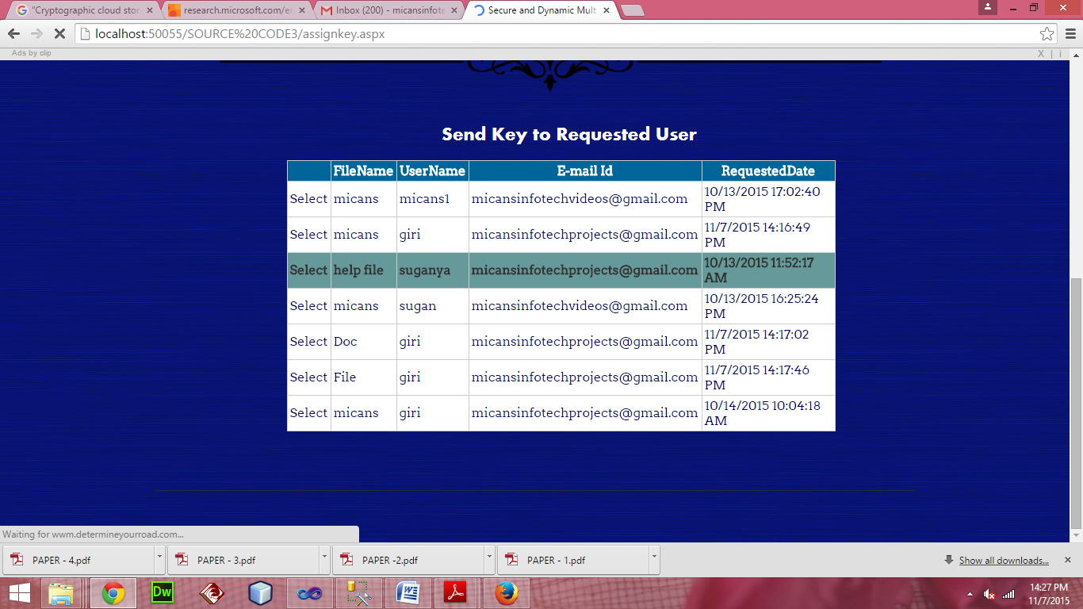

SYSTEM TESTING

The purpose of testing is to discover errors. Testing is the process of trying to discover every conceivable fault or weakness in a work product. It provides a way to check the functionality of components, sub assemblies, assemblies and/or a finished product. It is the process of exercising software with the intent of ensuring that the Software system meets its requirements and user expectations and does not fail in an unacceptable manner. There are various types of test. Each test type addresses a specific testing requirement.

**TYPES OF TESTS:**

Testing is the process of trying to discover every conceivable fault or weakness in a work product. The different type of testing are given below:

**UNIT TESTING:**

Unit testing involves the design of test cases that validate that the internal program logic is functioning properly, and that program inputs produce valid outputs. All decision branches and internal code flow should be validated. It is the testing of individual software units of the application .it is done after the completion of an individual unit before integration.

This is a structural testing, that relies on knowledge of its construction and is invasive. Unit tests perform basic tests at component level and test a specific business process, application, and/or system configuration. Unit tests ensure that each unique path of a business process performs accurately to the documented specifications and contains clearly defined inputs and expected results.

**INTEGRATION TESTING:**

Integration tests are designed to test integrated software components to determine if they actually run as one program. Testing is event driven and is more concerned with the basic outcome of screens or fields. Integration tests demonstrate that although the components were individually satisfaction, as shown by successfully unit testing, the combination of components is correct and consistent. Integration testing is specifically aimed at exposing the problems that arise from the combination of components.

**FUNCTIONAL TEST:**

Functional tests provide systematic demonstrations that functions tested are available as specified by the business and technical requirements, system documentation, and user manuals.

Functional testing is centered on the following items:

**Valid Input :** identified classes of valid input must be accepted.

**Invalid Input :** identified classes of invalid input must be rejected.

**Functions :** identified functions must be exercised.

**Output :** identified classes of application outputs must be exercised.

**Systems/ Procedures :** interfacing systems or procedures must be invoked.

Organization and preparation of functional tests is focused on requirements, key functions, or special test cases. In addition, systematic coverage pertaining to identify Business process flows; data fields, predefined processes, and successive processes must be considered for testing. Before functional testing is complete, additional tests are identified and the effective value of current tests is determined.

**SYSTEM TEST:**

System testing ensures that the entire integrated software system meets requirements. It tests a configuration to ensure known and predictable results. An example of system testing is the configuration oriented system integration test. System testing is based on process descriptions and flows, emphasizing pre-driven process links and integration points.

**WHITE BOX TESTING:**

White Box Testing is a testing in which in which the software tester has knowledge of the inner workings, structure and language of the software, or at least its purpose. It is purpose. It is used to test areas that cannot be reached from a black box level.

**BLACK BOX TESTING:**

Black Box Testing is testing the software without any knowledge of the inner workings, structure or language of the module being tested. Black box tests, as most other kinds of tests, must be written from a definitive source document, such as specification or requirements document, such as specification or requirements document. It is a testing in which the software under test is treated, as a black box .you cannot “see” into it. The test provides inputs and responds to outputs without considering how the software works.

**UNIT TESTING:**

Unit testing is usually conducted as part of a combined code and unit test phase of the software lifecycle, although it is not uncommon for coding and unit testing to be conducted as two distinct phases.

**Test strategy and approach**

Field testing will be performed manually and functional tests will be written in detail.

**Test objectives**

* All field entries must work properly.
* Pages must be activated from the identified link.
* The entry screen, messages and responses must not be delayed.

**Features to be tested**

* Verify that the entries are of the correct format
* No duplicate entries should be allowed
* All links should take the user to the correct page.

# INTEGRATION TESTING:

Software integration testing is the incremental integration testing of two or more integrated software components on a single platform to produce failures caused by interface defects.

The task of the integration test is to check that components or software applications, e.g. components in a software system or – one step up – software applications at the company level – interact without error.

**Test Results:** All the test cases mentioned above passed successfully. No defects encountered.

**ACCEPTANCE TESTING:**

User Acceptance Testing is a critical phase of any project and requires significant participation by the end user. It also ensures that the system meets the functional requirements.

**Test Results:** All the test cases mentioned above passed successfully. No defects encountered.

### IMPLEMENTATION

Implementation is the stage of the project when the theoretical design is turned out into a working system. Thus it can be considered to be the most critical stage in achieving a successful new system and in giving the user, confidence that the new system will work and be effective. The implementation stage involves careful planning, investigation of the existing system and it’s constraints on implementation, designing of methods to achieve changeover and evaluation of changeover methods.

**MODULES:**

A module is a part of a program. Programs are composed of one or more independently developed modules that are not combined until the program is linked. A single module can contain one or several routines. Our project modules are given below:

* Cloud user
* Cloud server
* Data Owner
* Search files

**CLOUD SERVER:**

Cloud server stores the encrypted document collection *C* and the encrypted searchable tree index *I* for data owner. Upon receiving the trapdoor *TD* from the data user, the cloud server executes search over the index tree *I*, and finally returns the corresponding collection of top-*k* ranked encrypted documents. Besides, upon receiving the update information from the data owner, the server needs to update the index *I* and document collection *C* according to the received information.

**CLOUD USER:**

Cloud users are authorized ones to access the documents of data owner. With *t* query keywords, the authorized user can generate a trapdoor *TD* according to search control mechanisms to fetch *k* encrypted documents from cloud server. Then, the data user can decrypt the documents with the shared secret key.

**DATA OWNER:**

Data owner has a collection of documents *F* =*{f*1*; f*2*; :::; fn}* that he wants to outsource to the cloud server in encrypted form while still keeping the capability to search on them for effective utilization. In our scheme, the data owner firstly builds a secure searchable tree index *I* from document collection *F*, and then generates an encrypted document collection *C* for *F*. Afterwards, the data owner outsources the encrypted collection *C* and the secure index *I* to the cloud server, and securely distributes the key information of trapdoor generation (including keyword IDF values) and document decryption to the authorized data users.

**SEARCH FILE:**

The search process of the UDMRS scheme is a recursive procedure upon the tree, named as “Greedy Depth first Search (GDFS)” algorithm. We construct a result list denoted as *RList*, whose element is defined as *⟨RScore; FID⟩*. Here, the *RScore* is the relevance score of the document *fFID* to the query, which is calculated according to Formula (1). The *RList* stores the *k* accessed documents with the largest relevance scores to the query. The elements of the list are ranked in descending order according to the *RScore*, and will be updated timely during the search process.

**CONCLUSION**

In this project, a secure, efficient and dynamic search scheme is proposed, which supports not only the accurate multi-keyword ranked search but also the dynamic deletion and insertion of documents. We construct a special keyword balanced binary tree as the index, and propose a “Greedy Depth-first Search” algorithm to obtain better efficiency than linear search. In addition, the parallel search process can be carried out to further reduce the time cost. The security of the scheme is protected against two threat models by using the secure kNN algorithm. Experimental results demonstrate the efficiency of our proposed scheme.